Software Requirements Specification

for

<POS System for Coffee Shops>

Version 2.0 approved

Prepared by <Kevin Ngo>

<California State University, Los Angeles>

<September 22, 2019>

Table of Contents

Table of Contents ii

Revision History ii

1. Introduction 1

1.1 Purpose 1

1.2 Document Conventions 1

1.3 Intended Audience and Reading Suggestions 1

1.4 Product Scope 1

1.5 References 1

2. Overall Description 2

2.1 Product Perspective 2

2.2 Product Functions 2

2.3 User Classes and Characteristics 5

2.4 Operating Environment 5

2.5 Design and Implementation Constraints 5

2.6 User Documentation 6

2.7 Assumptions and Dependencies 6

3. External Interface Requirements 7

3.1 User Interfaces 7

3.2 Hardware Interfaces 24

3.3 Software Interfaces 24

3.4 Communications Interfaces 24

4. System Features 24

4.1 Table Visualization 24

4.2 Menu Visualization 27

4.3 Status Visualization 29

4.4 Employee Visualization 30

4.5 Inventory Visualization 32

4.6 Statistic Visualization 36

5. Other Nonfunctional Requirements 38

5.1 Performance Requirements 38

5.2 Safety Requirements 38

5.3 Security Requirements 38

5.4 Software Quality Attributes 38

5.5 Business Rules 38

6. Other Requirements 40

Revision History

|  |  |  |  |
| --- | --- | --- | --- |
| **Name** | **Date** | **Reason for Changes** | **Version** |
| POS System for Coffee Shops | 09/11/2019 | First time commit | 1.0 |
| POS System for Coffee Shops | 09/22/2019 | Updated section 2,3,4,5, and 6 | 2.0 |

# Introduction

## Purpose

The purpose of this document is to present a detailed description of the open-source software POS System for Coffee Shops. It will explain the purpose and features of the software, the interfaces of the software, what the software will do and the constraints under which it must operate. This document is intended for users of the software and potential developers.

## Document Conventions

This Document was created based on the IEEE template for System Requirement Specification Documents.

## Intended Audience and Reading Suggestions

* Typical Users, such as students, who want to use POS System for Coffee Shops for learning how to implement a simple web application which will manage a coffee shop as a real SMB.
* Programmers who are interested in working on the project by further developing it or fix existing bugs.

## Product Scope

* POS System for Coffee Shops is a simple web application that people can use to simply manage their coffee with basic features. Users can use it to set up their menu and manage their staff as well as items and inventory in their store. Store’s data is analyzed and presents as graphs to help the business can predict customer’s habit to provide better service.

## References

POS System for Coffee Shops website:

https://

POS System for Coffee Shops GitHub page:

<https://github.com/fkvn/POS-System-for-Coffee-Shops>

IEEE Template for System Requirement Specification Documents:

<https://goo.gl/nsUFwy>

# Overall Description

## Product Perspective

POS System for Coffee Shops was developed for everyone who wants either just experiment with it to understand how it works or wants to use them as a management system of managing a SMB data. It can handle various features (setting up menu, managing staff, demonstrating store’s status and statistic) and supports predicting customer’s habit.

It is an open source project and it has a very active developer team to support it and provide feedback to users. It is a web application, so it can be run on Windows, Mac OS X and Linux if users can connect to the internet. On top of that, it is recommended to use latest versions of the popular browsers, such as Microsoft Edge, Firefox, or Chrome.

## Product Functions

Overview:

* There are 6 typical navigations tab on the top of every page: Home, Menu, Status, Employee, Inventory, and Statistic.
* If users are customers, the header area display login button and banner picture.
  + The main area is divided into 3 parts
    - Left hand side: display categories of menu.
    - Center: display items corresponding to selected category.
    - Right hand side: display top-selling items’ pictures as well as ads if applicable.
* If users are Admins, the header area displays log out button, and 6 typical navigations tab listed above. On top of that, it also displays banner picture as well.
* If users are Staff, the header area displays log out button, and 6 typical navigations tab listed above. However, they only can access to Home and Menu tab.
* There is a contact information area at the footer of every page.

Home page: Display all the list of tables in the store (for Admins and Staff.)

* + Search: search for a table by its name.
  + Sort-By: sort the list of tables by their attributes, such as name, status, time (time the table was starting serve), and cost.
  + Order-By: display the list of tables with ascending or descending order.
  + New Table: create a new table (for Admins only)
  + Non-imaging view: display the list of tables with its name only (non-images)
  + Clickable on table’s name: look at table detail information, including name, date, time, status, estimated order total, cost, and allow users to edit table’s name as well as delete the able.
    - Only Admins can see Edit and Delete buttons.
  + Edit Table’s name: update the table name (for Admins only)
  + Delete table: delete permanently table and its information (for Admins only)
  + Clickable on table’s image: display Table view
* Table view: Display table’s order information and provide basic features: (for Admins and Staff)
  + Overview:
    - Display list of items in the table’s order.
    - Be able to edit item’s quantity from the order’s list.
    - Be able to remove item from the order’s list.
  + Age range: select age range of the table’s customers.
  + Print order: print the list of items from the order.
  + Print receipt: print the receipt of the order.
  + Make Payment: make a payment for the table’s order.
  + Add new item: add a new item to the table’s order.

Menu Page: Display the list of categories and its corresponding items (for Admins, Staff and Customers)

* Search: search for a category and an item by their name.
* Order-By: ascending or descending.
* Add a new category. (for Admins)
* Add a new item. (for Admins)

Status Page: (for Admins only)

* Overview: Display daily report with the following information:
  + List of available tables.
  + List of staff who is currently working.
  + Top-selling items (5 items)
  + List of out-of-stock items
  + Daily income
  + A pie chart with top 4 categories.
* Print report: print daily report of the store.

Employee Page: (for Admins only)

* Overview:
  + Display a table with a list of employees.
  + Each row of the employee table includes id, name, employee number, date of hired and 2 operations: Edit and Delete.
* Search: search for an employee by its attribute.
* Order-By: ascending or descending.
* Edit: update employee’s information.
* Delete: remove an employee from the system.
* Clickable employee name: display employee’s detail information.

Inventory Page: (for Admins only)

* Overview:
  + Display a table with a list of inventories.
  + Each row of the inventory table includes id, name, status, type and 2 operations: Edit and Delete.
* Search: search for an inventory by its name.
* Sort-By: sort the inventories by their id, name, status, or type.
* Order-By: ascending or descending.
* New inventory: add a new inventory.
* Clickable inventory name: display inventory view
* Inventory view: (for Admins only)
  + Overview:
    - Display a table with a list of all items of the inventory.
    - Each row of the inventory item list includes id, name, quantity, unit and 2 operations: Edit and Delete.
    - Allow user to navigate to another inventory view by clicking a button.
  + Search: search for an inventory item by its name.
  + Sort-By: sort the inventory items by their id, name, quantity, or unit.
  + Order-By: ascending or descending.
  + New item: add a new item to the inventory

Statistic Page: (for Admins only)

* Overview:
  + Display top-selling items (up to 6) by daily, monthly, and yearly.
  + Display top-selling items by bar graph.
  + Allow user to pick a date, month, or year.
* Present: display top-selling items of current day, month, or year.

## User Classes and Characteristics

* Typical Users, such as the coffee shop owners who want to use POS System for Coffee Shops to manage their store.
* Programmers who are interested in working on the project by further developing it or fix existing bugs.

## Operating Environment

* Windows 7.
* Windows 10.
* Mac OS X
* Linux
* For old Windows versions, such as Windows 2000, XP, Vista, etc. some functions might be limited by the operating system.

## Design and Implementation Constraints

POS System for Coffee Shops is developed in Node.js. Node.js is an open source, cross-platform runtime environment for developing server-side and networking applications. Node.js applications are written in JavaScript and can be run within the Node.js runtime on OS X, Microsoft Windows, and Linux.

It uses a modular design where every feature is wrapped into a separate module and the modules depend on each other through well-written APIs. There are several APIs available to make plugin development easy.

## Assumptions and Dependencies

POS System for Coffee Shops is developed in Node.js and therefore requires Node.js to be installed on the user’s system (for developers). The lasted stable versions of POS System for Coffee Shops requires Node.js version 10.16.3 or higher. This applies to Windows, Linux, and Mac OS X users.

# External Interface Requirements

## User Interfaces

1. 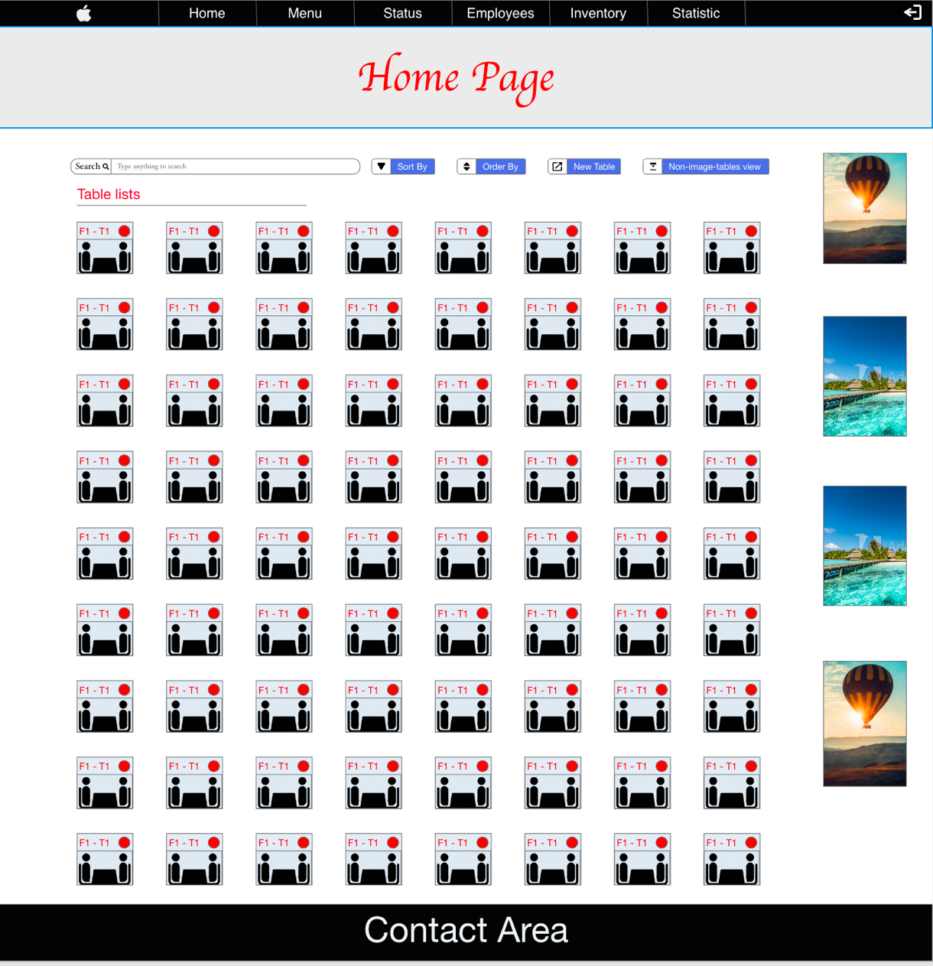Home page screen
2. 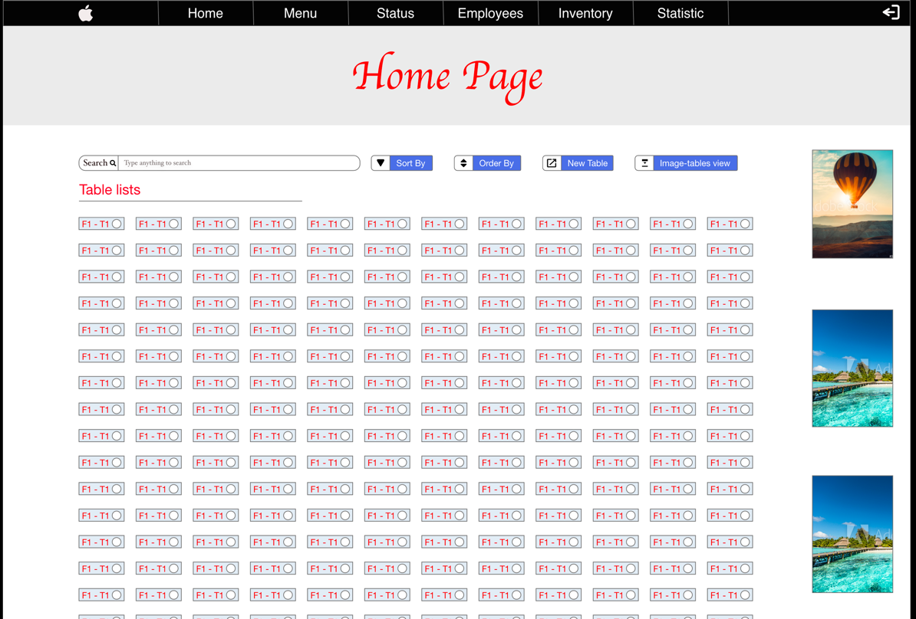Non-image table view
3. New table screen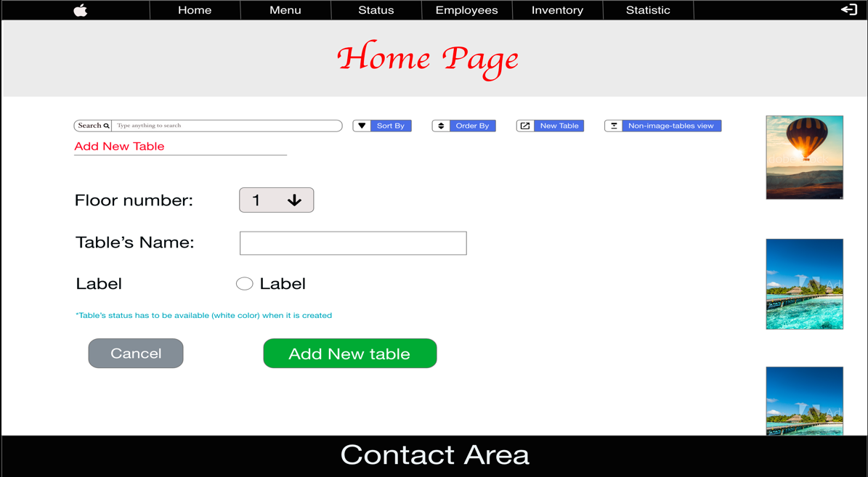
4. Table detail screen

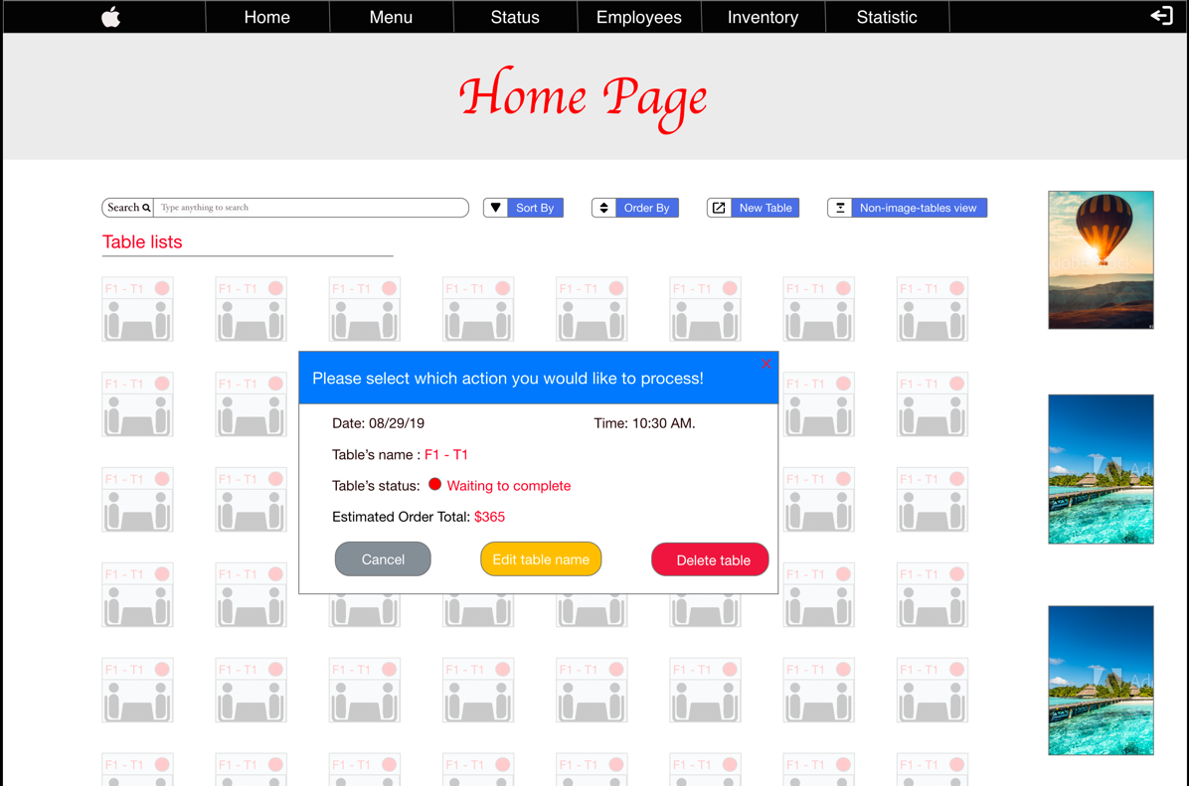

1. Edit table name screen

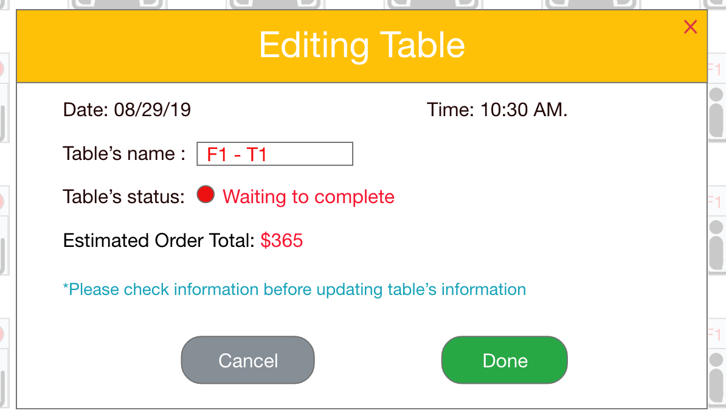

1. Delete table name screen

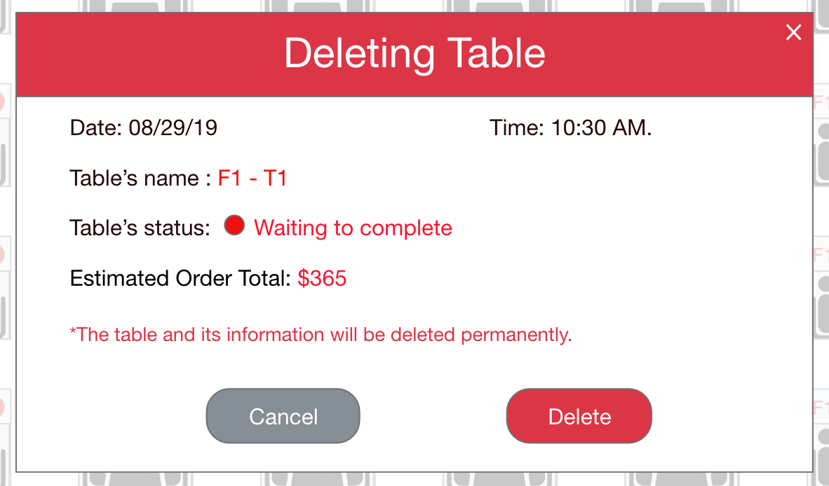

1. 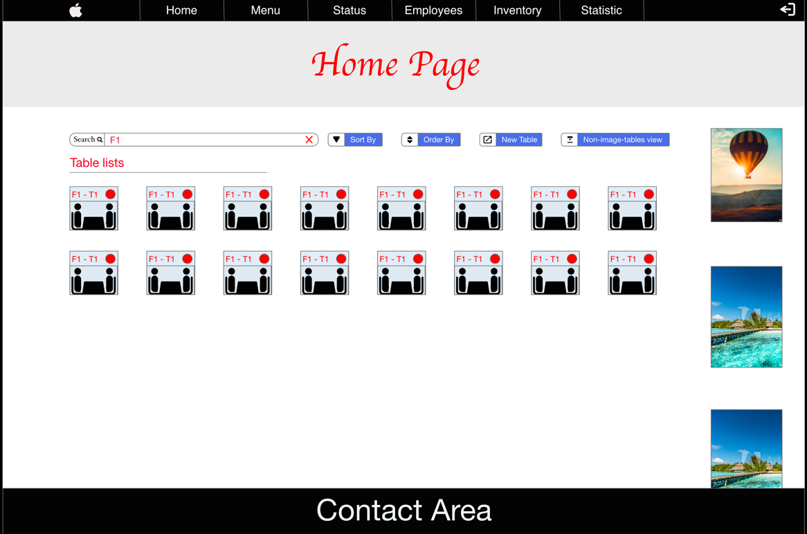 Search table screen

1. Sort table

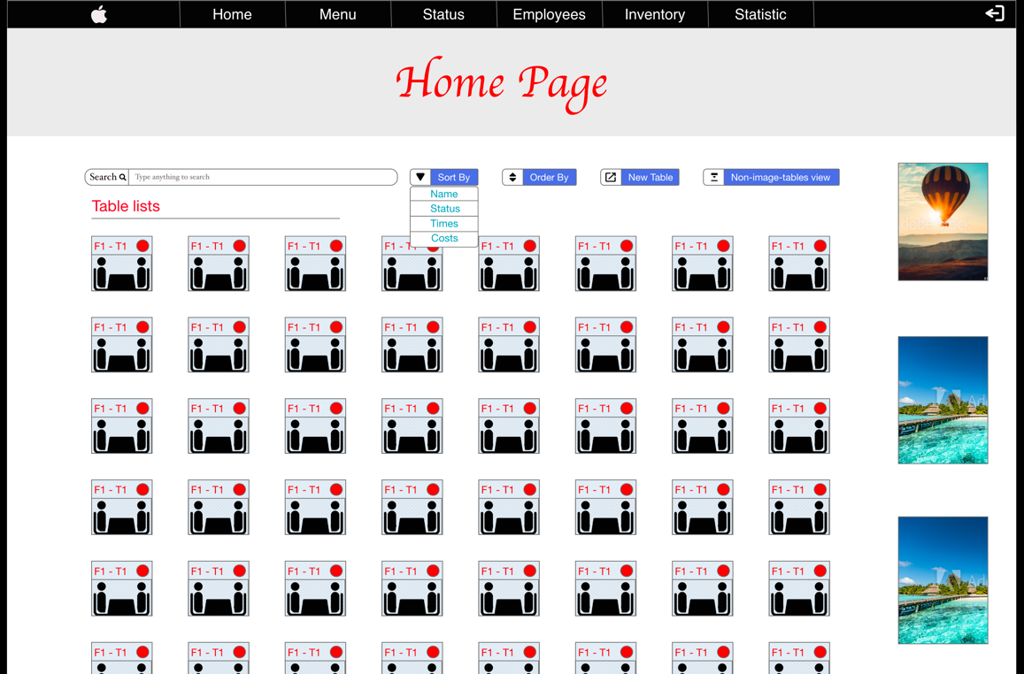

1. Order-by table

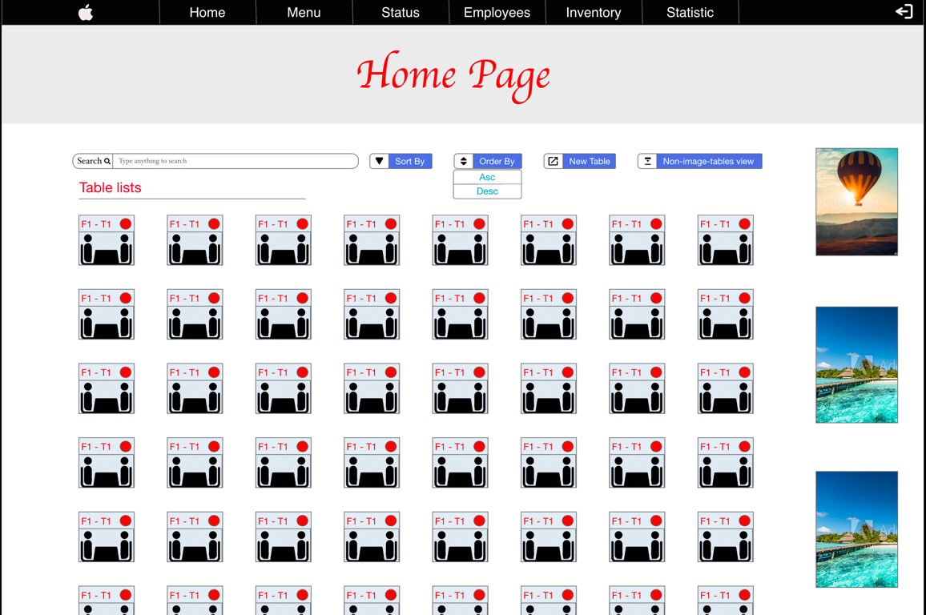

1. Table view

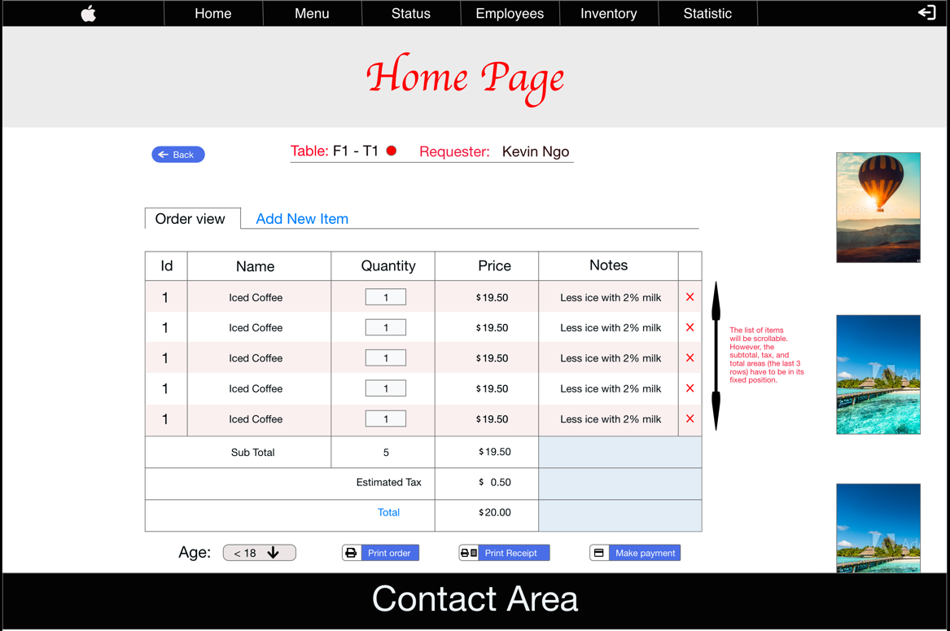

1. Add new item

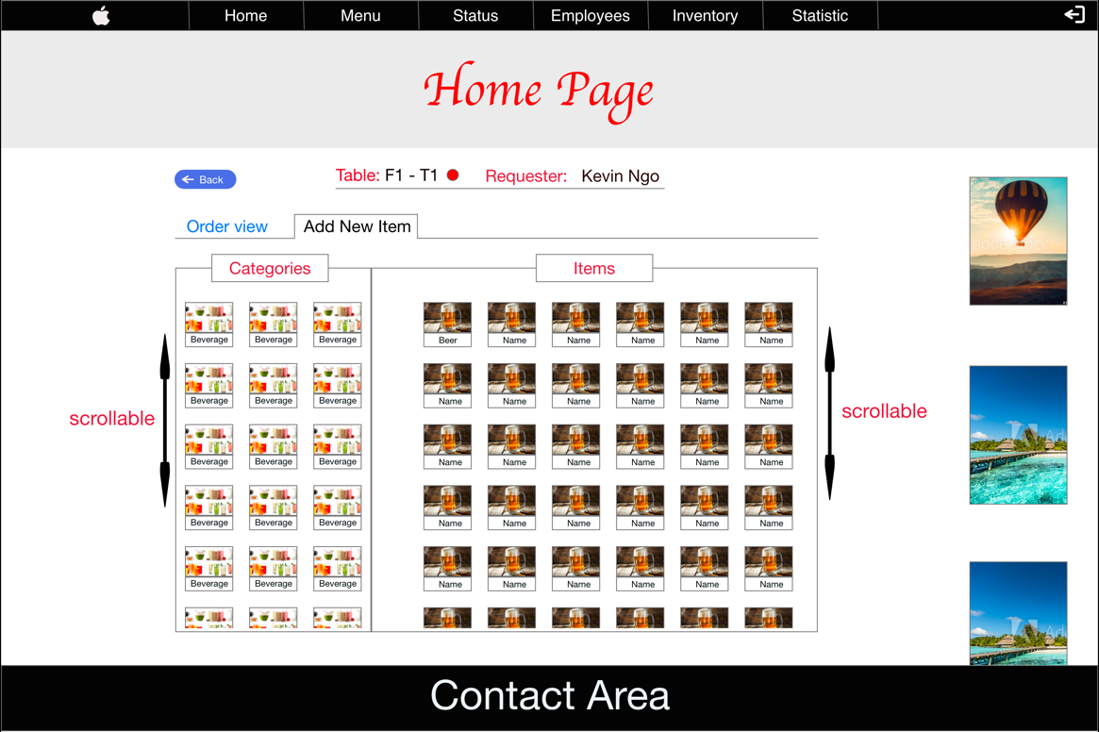

1. Menu page

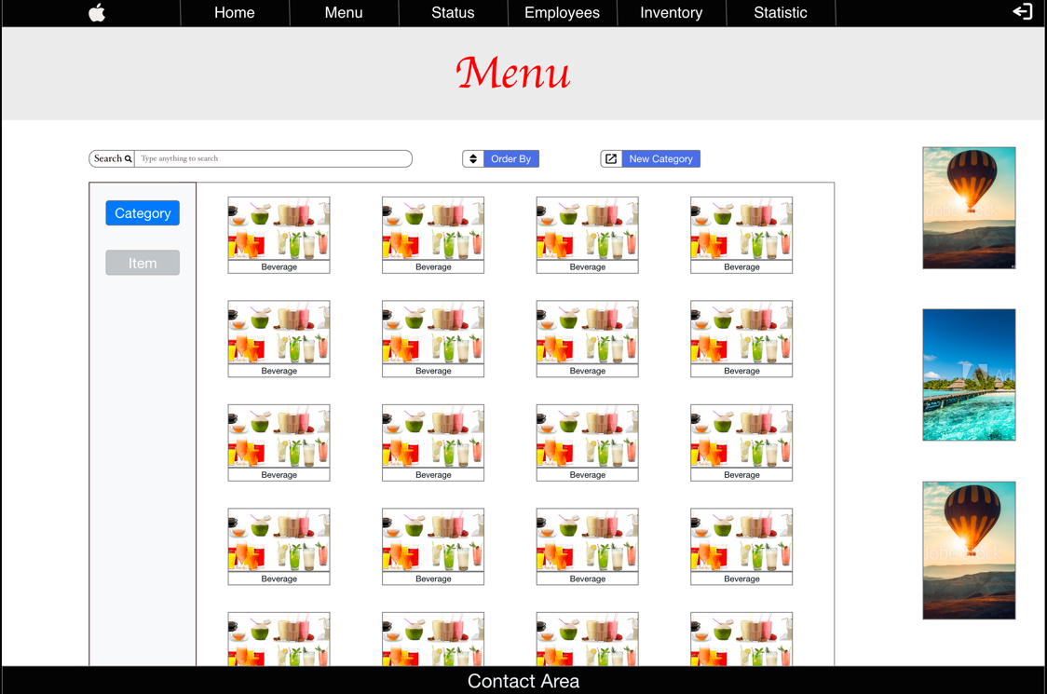

1. New Category

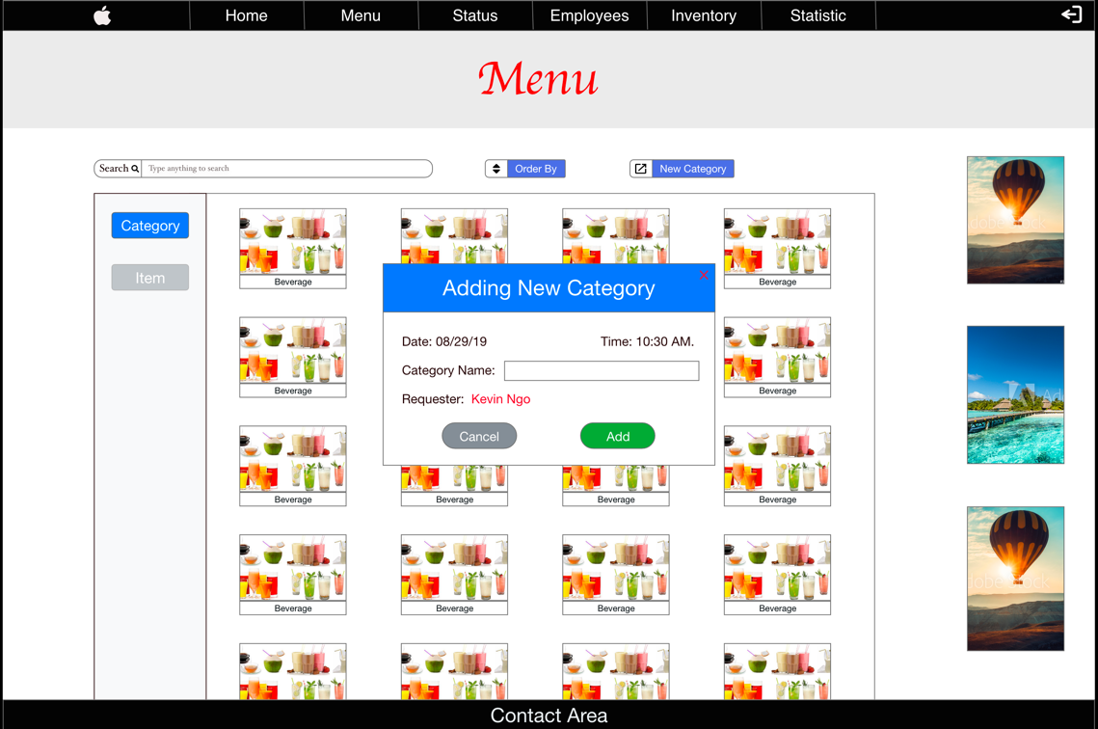

1. Menu Page (items)

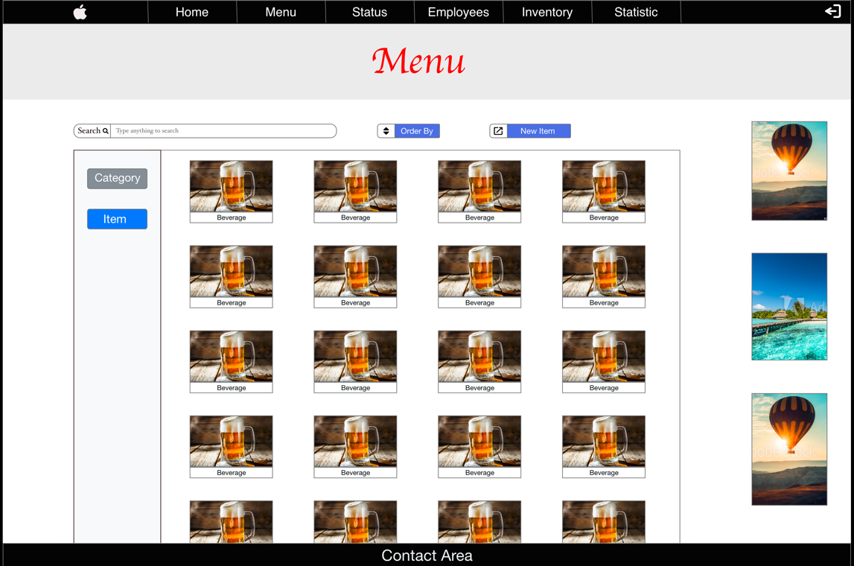

1. New item

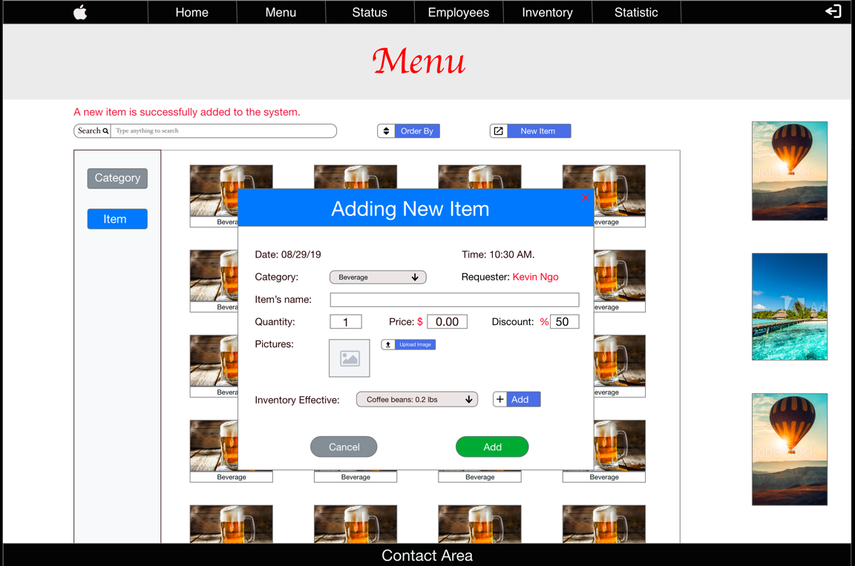

1. New effective inventory

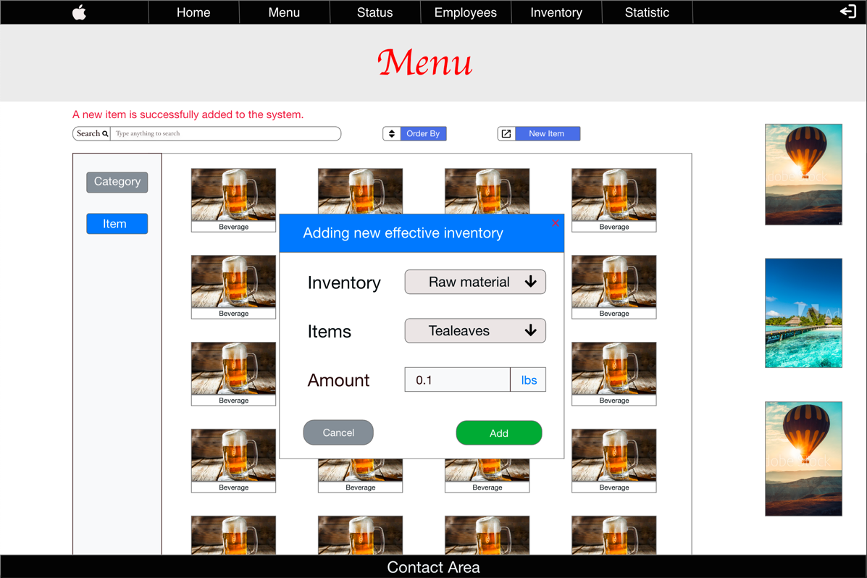

1. 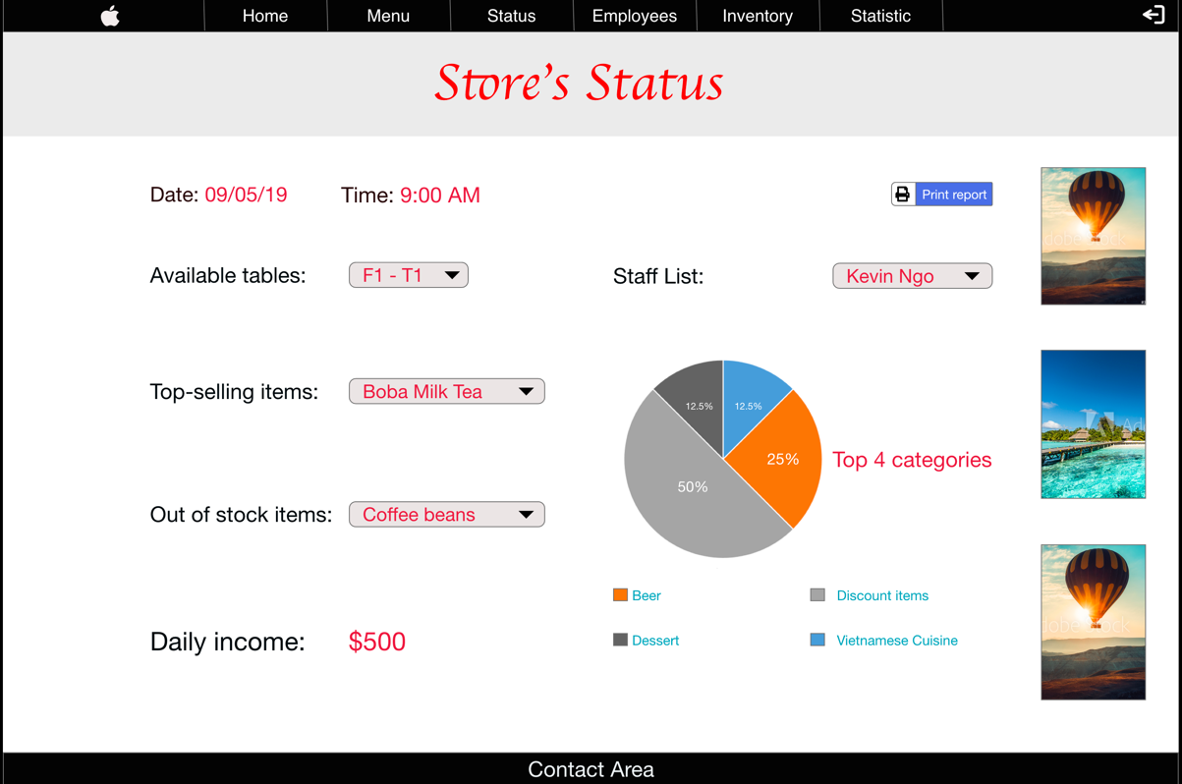 Status Page
2. 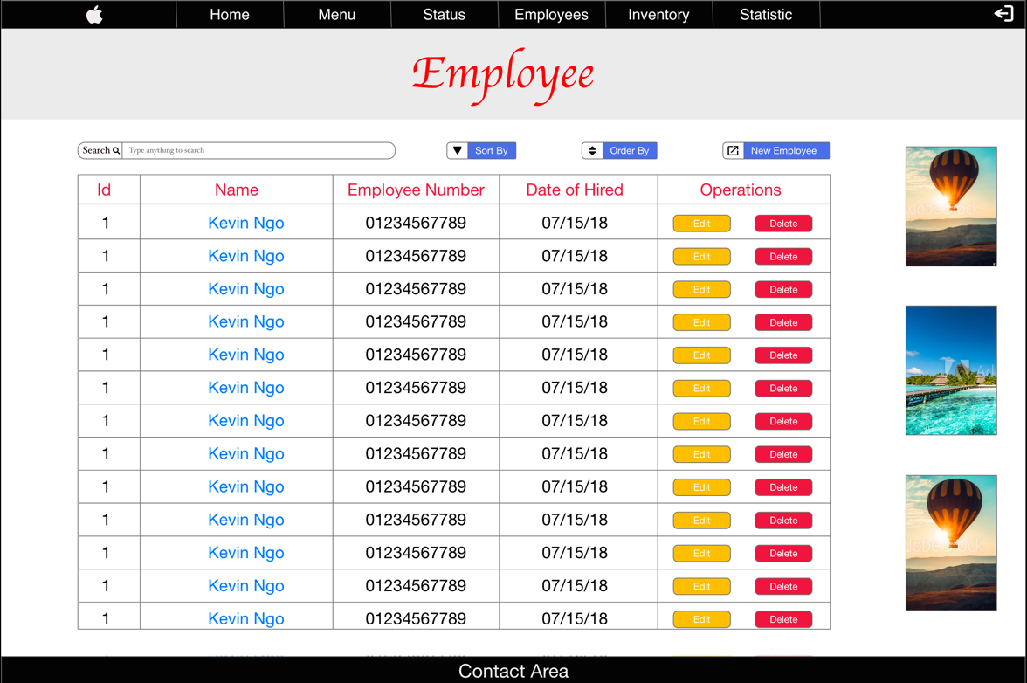 Employee Page
3. Employee detail information

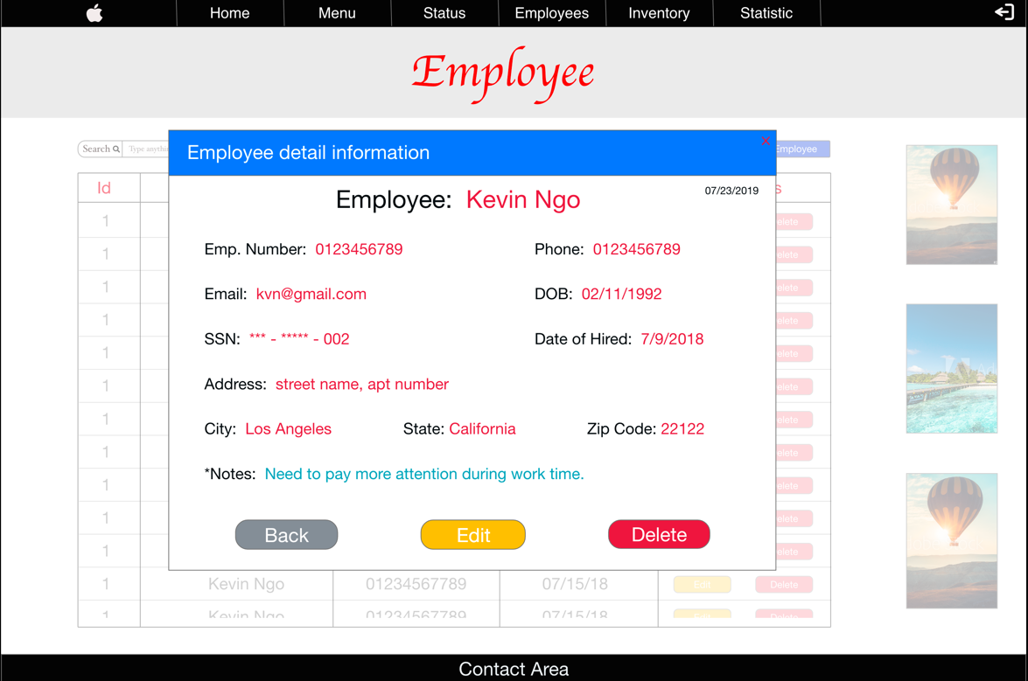

1. 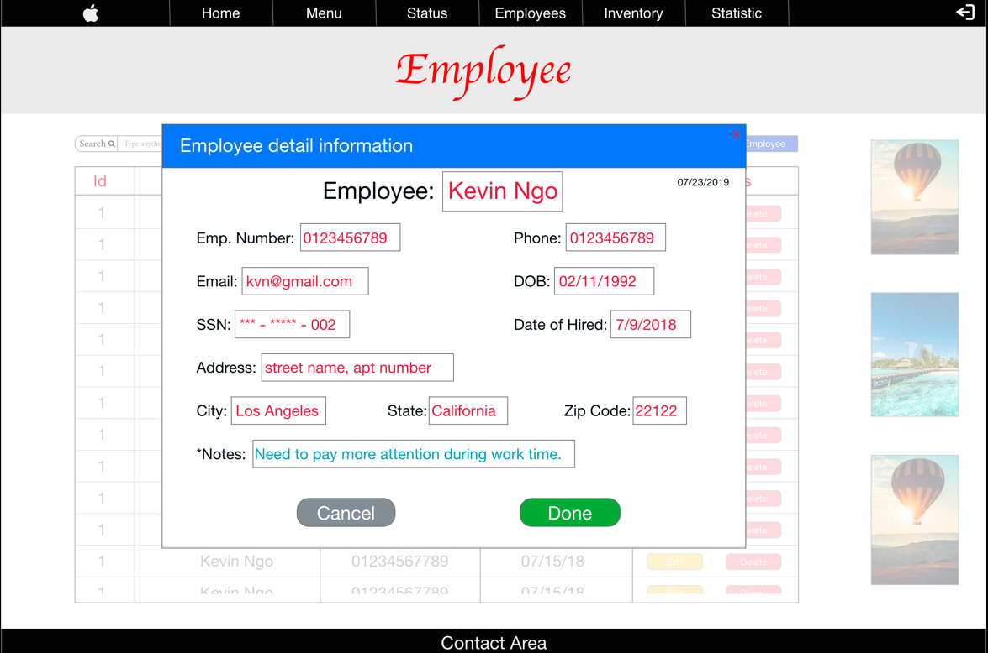 Edit employee information
2. Delete employee

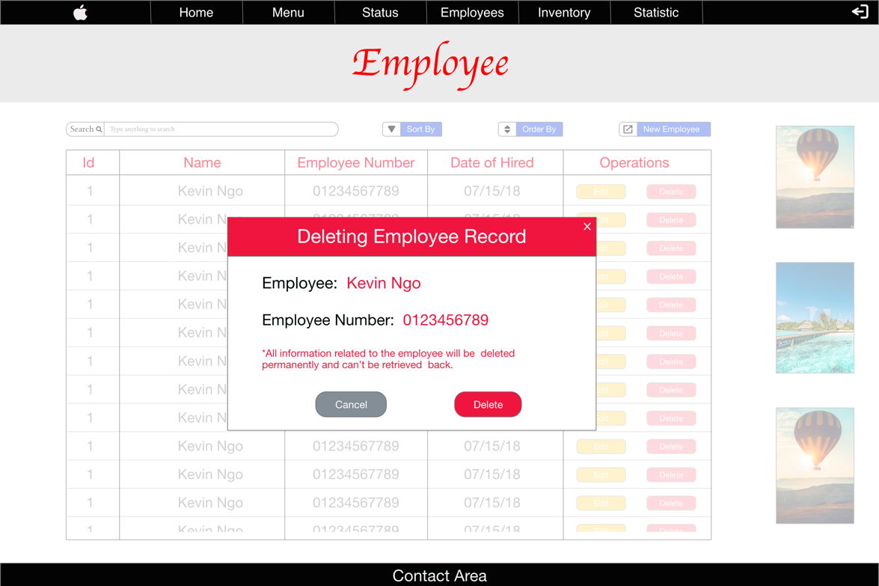

1. Add new employee

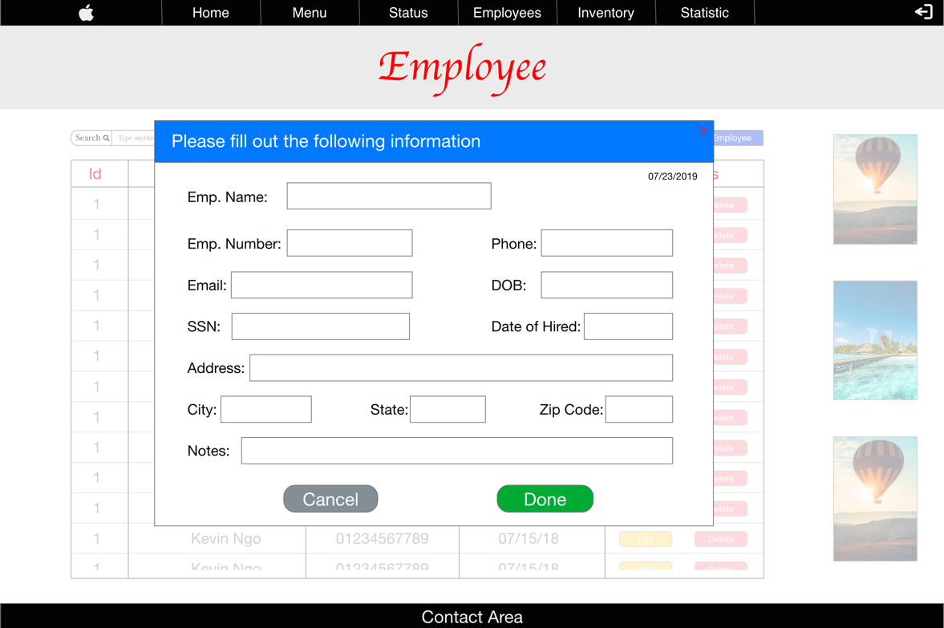

1. Inventory page

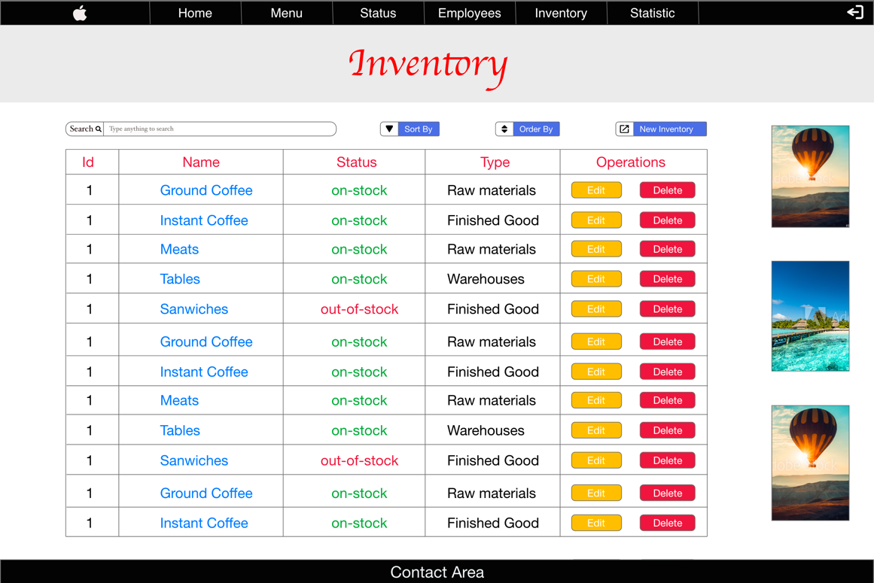

1. 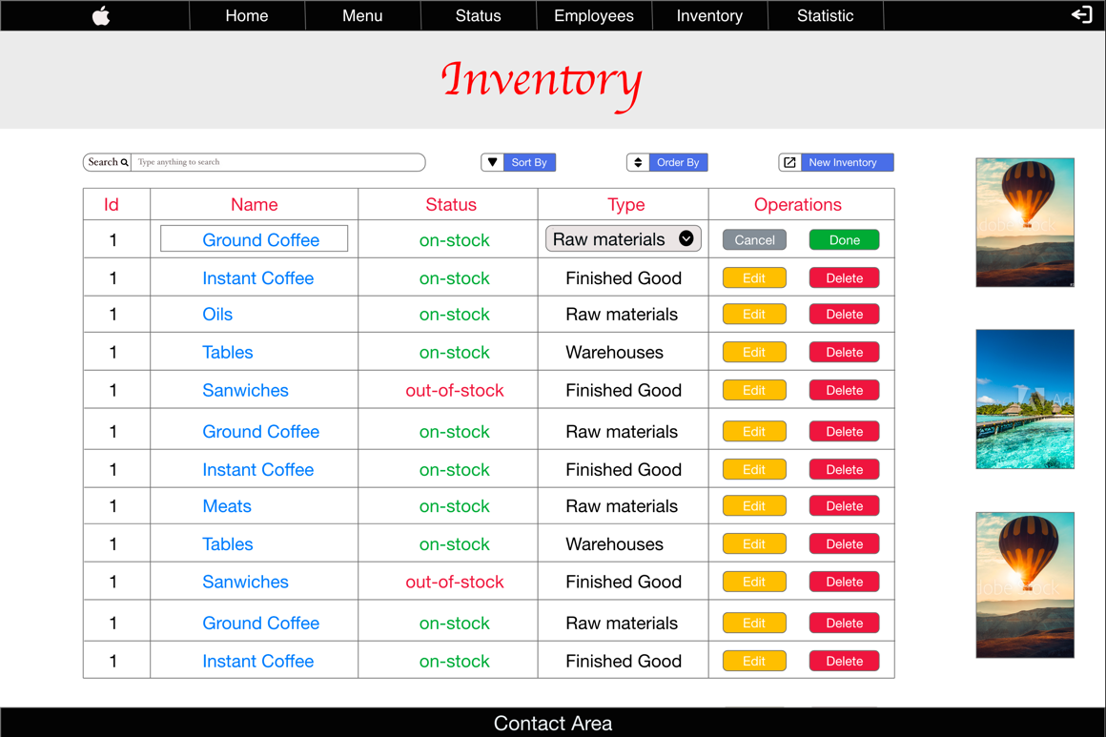Edit inventory
2. Delete inventory

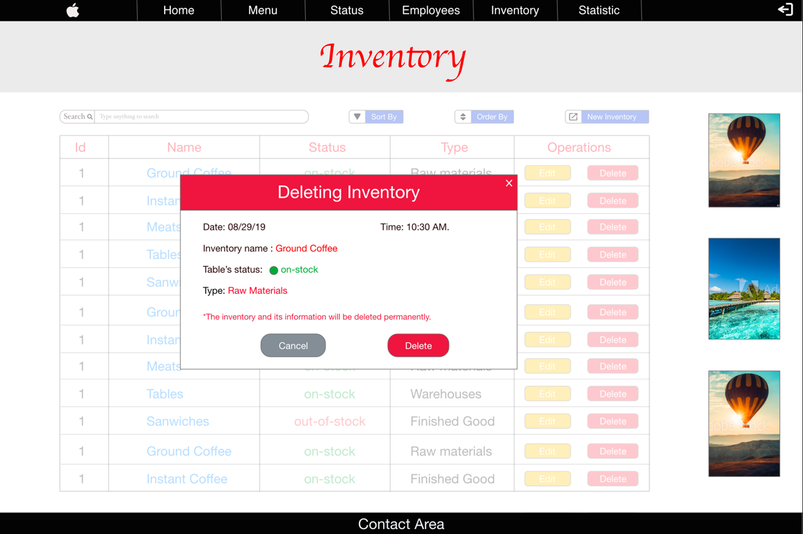

1. Add new inventory

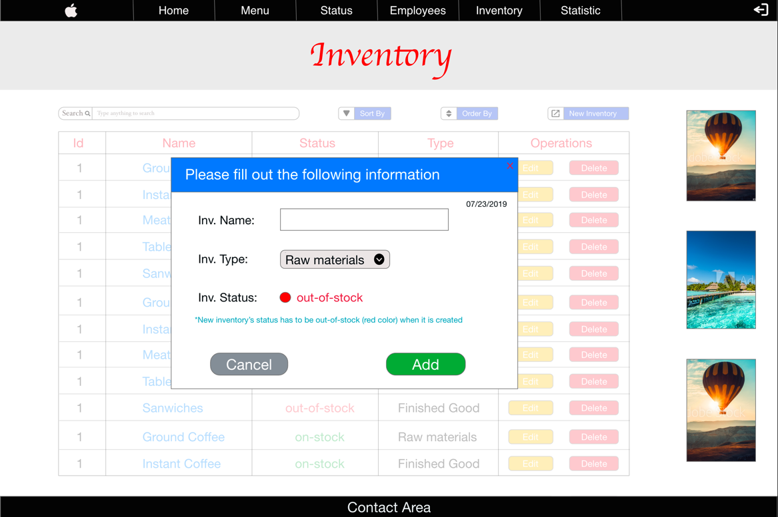

1. Inventory-item page

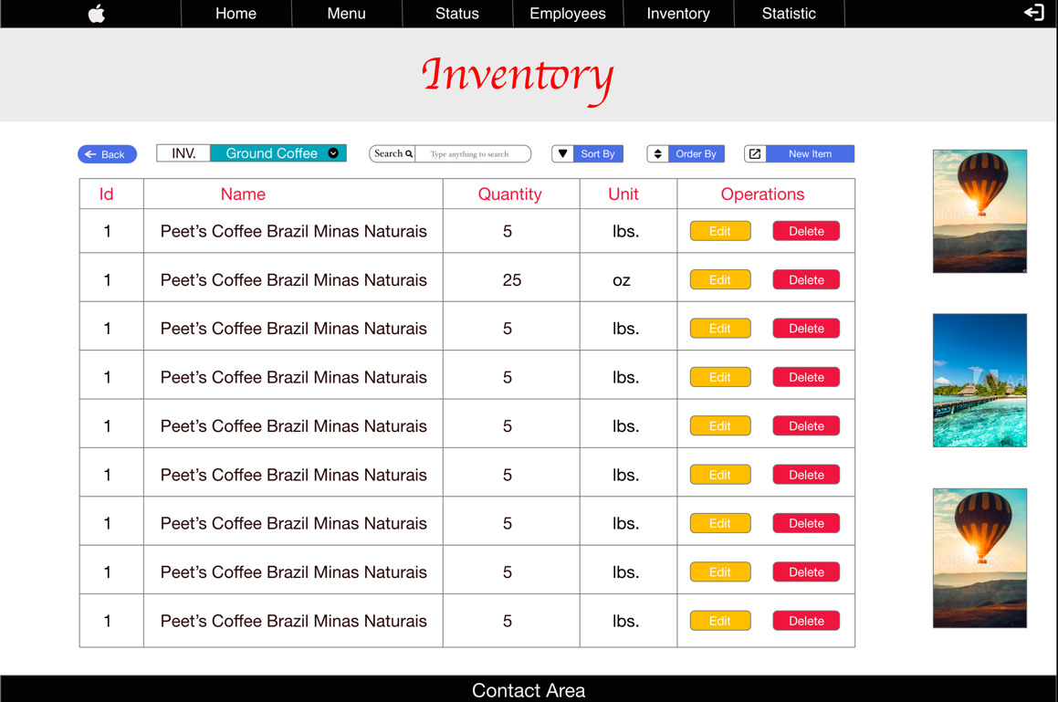

1. Edit inventory-item

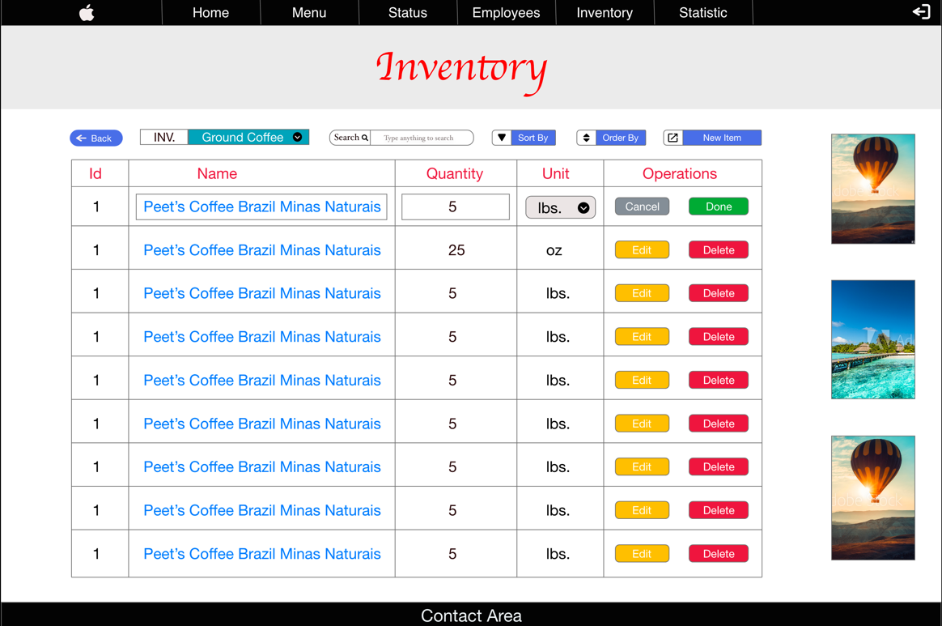

1. Delete inventory-item

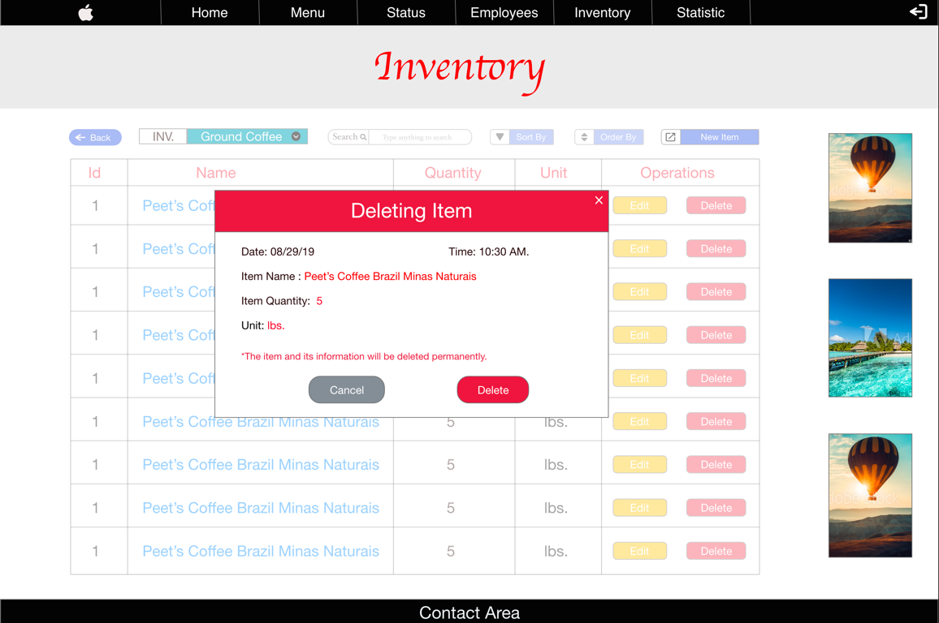

1. Add new inventory-item

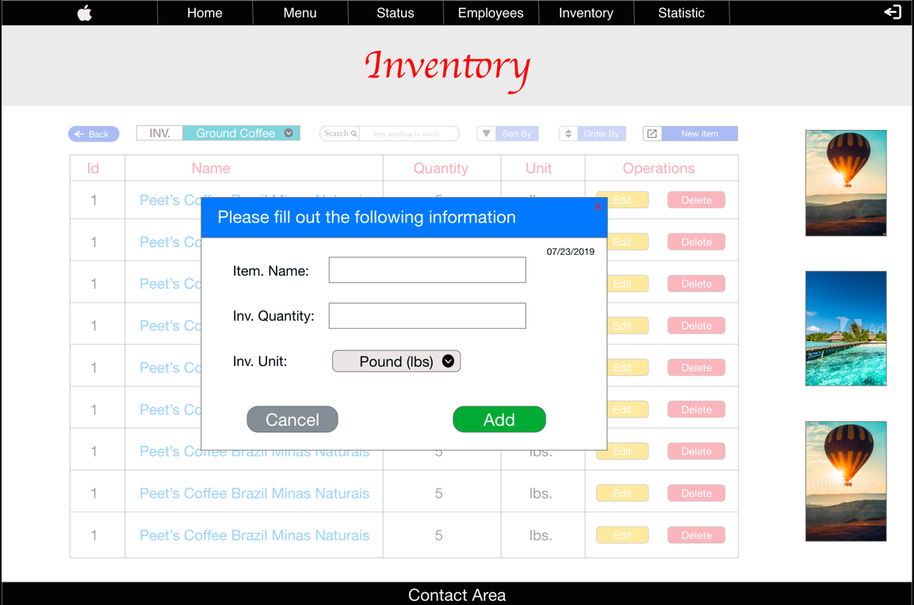

1. Statistic (Daily view)

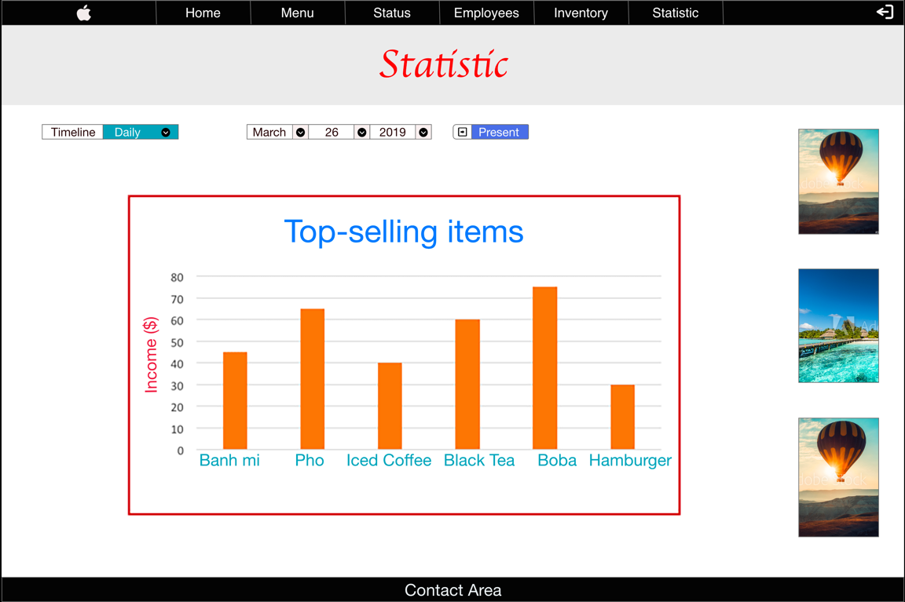

1. Statistic (Monthly view)

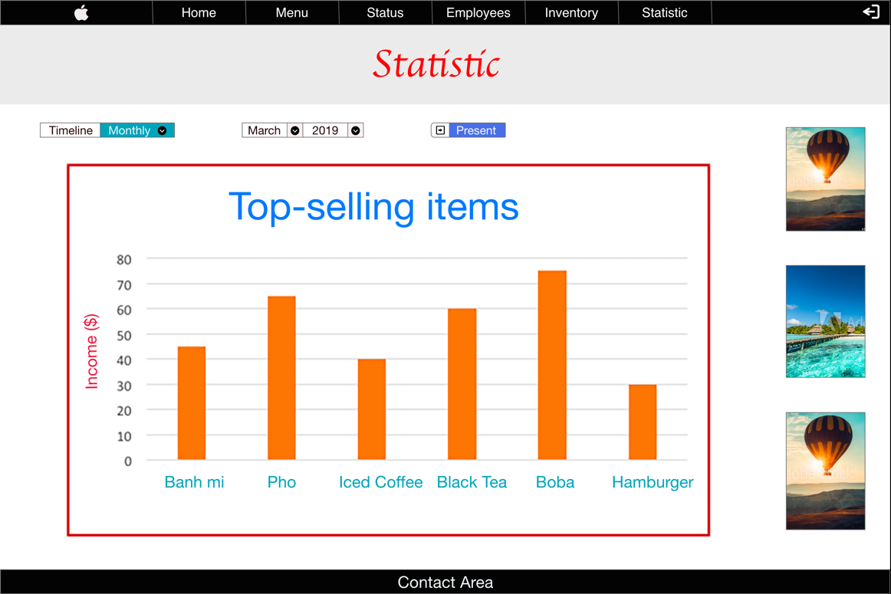

1. Statistic (Yearly view)

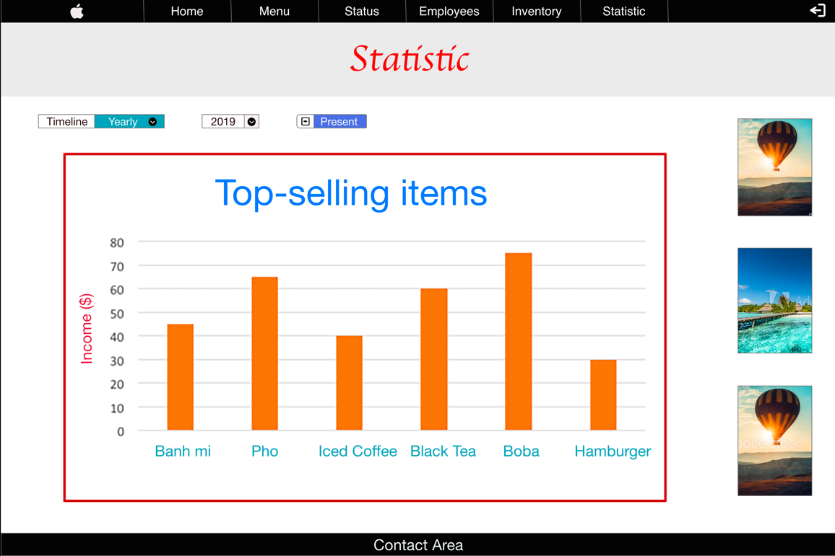

## Hardware Interfaces

There are no special hardware requirements of POS System for Coffee Shops.

## Software Interfaces

POS System for Coffee Shops requires Node.js to be installed as mentioned above.

POS System for Coffee Shops can relate to a MySQL, or PostgreSQL database to manage store’s data.

## Communications Interfaces

POS System for Coffee Shops requires an internet connection to use the web application, install new plugins as well as update some of its components (APIs, modules etc.).

# System Features

This section demonstrates POS System for Coffee Shops most prominent features and explains how they can be used and the results they will give back to the user.

## Table Visualization

Users can directly interact with table and its operations. For example, users can look at table detail and be able to edit as well as delete table information.

Example of editing table name:

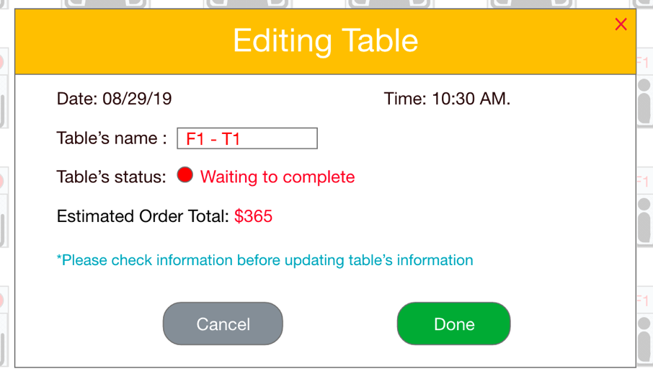

Example of deleting table:

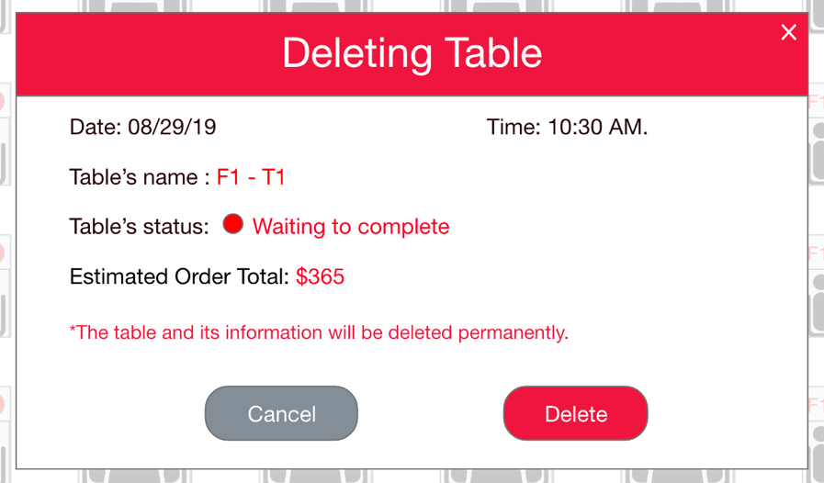

Users can also use the new table button to create a new table as the following example:

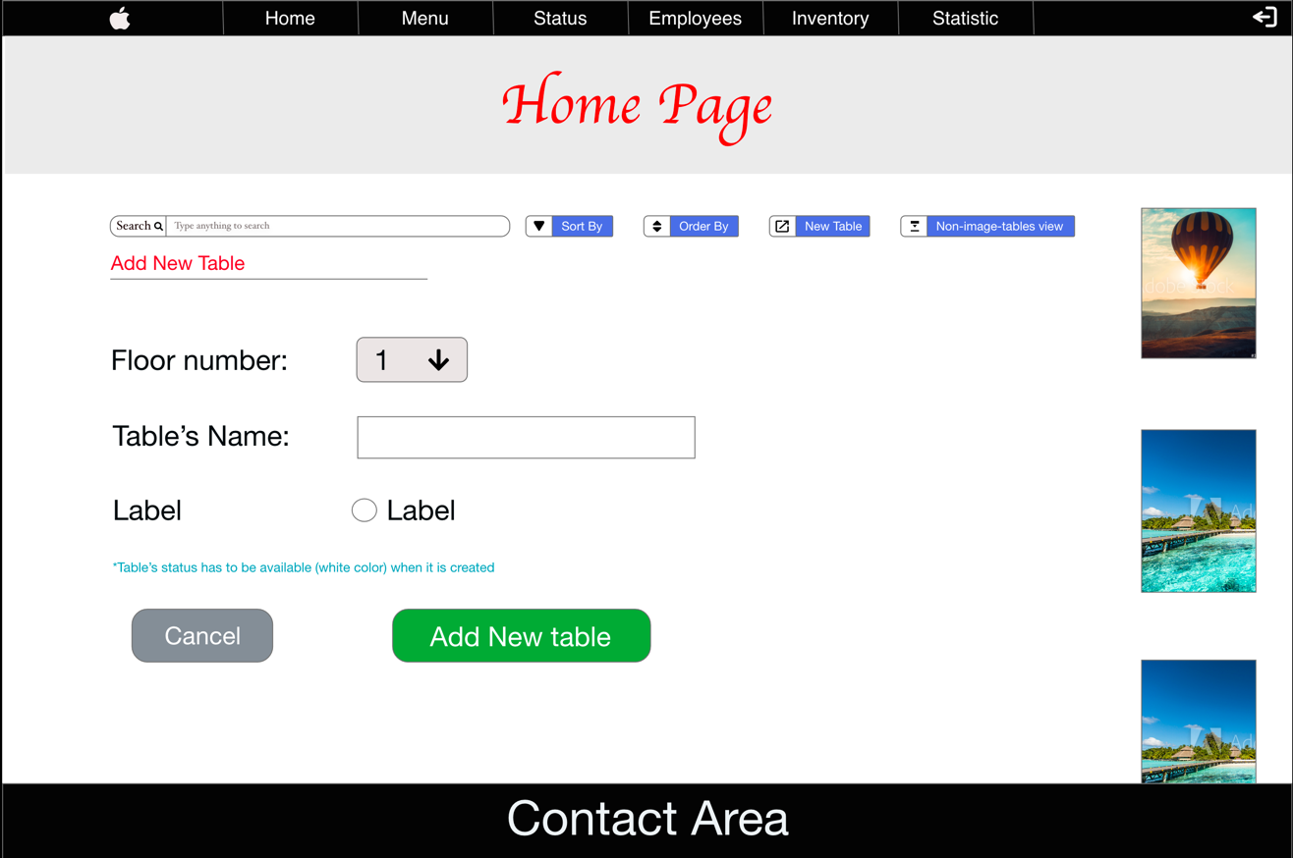

On top of that, when users click on table image, it will direct to the table view displaying table’s order.

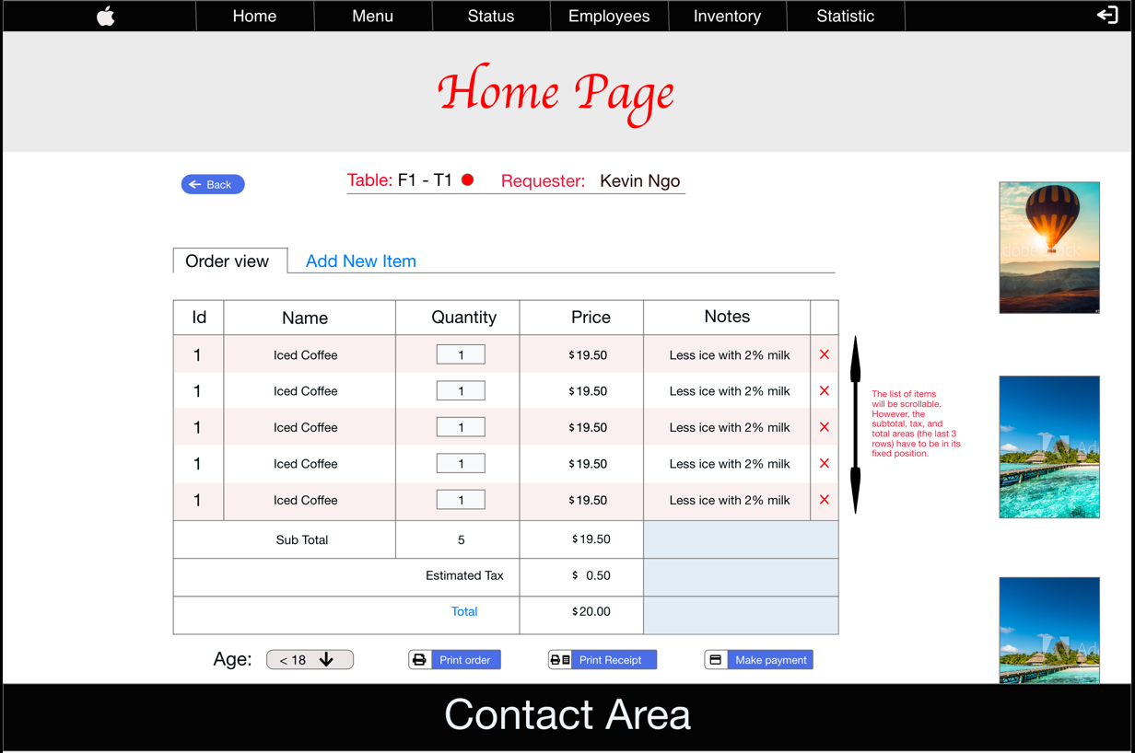

In the table view, users can perform add new item function to add a new item to the current order.

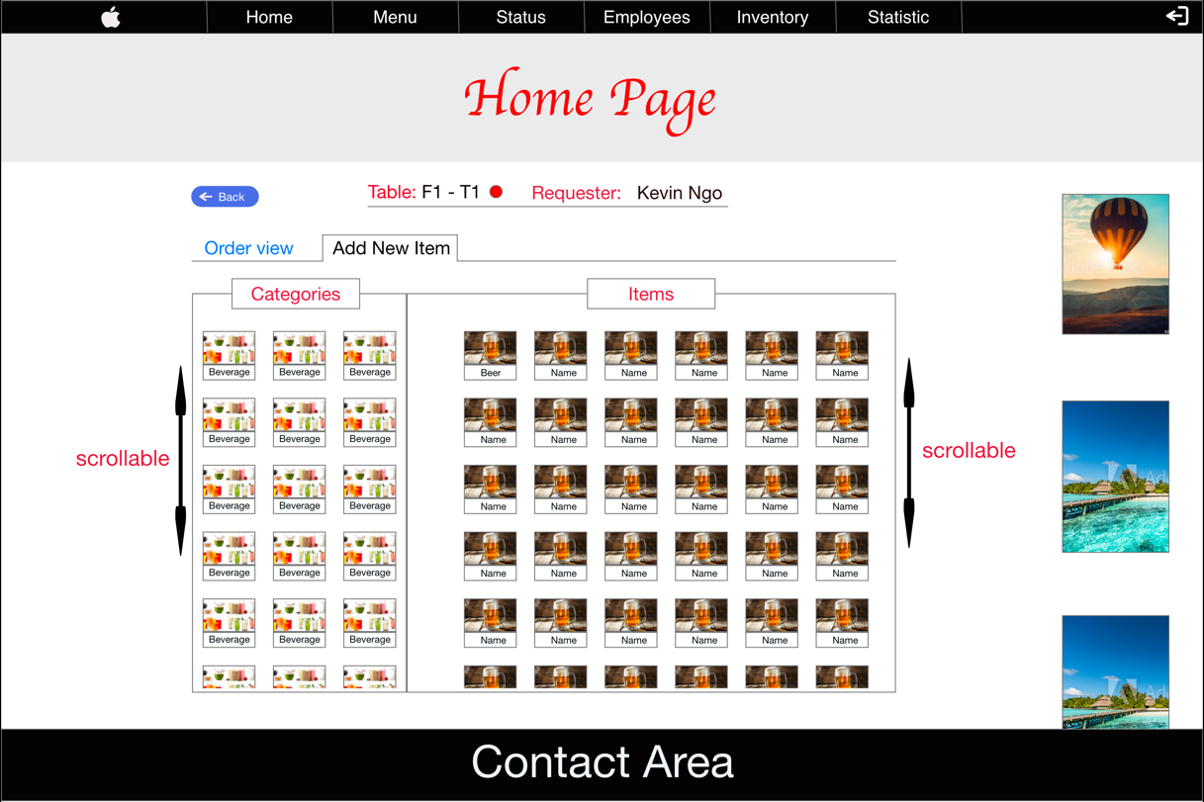

## Menu Visualization

On the menu page, users can select category and its corresponding items.

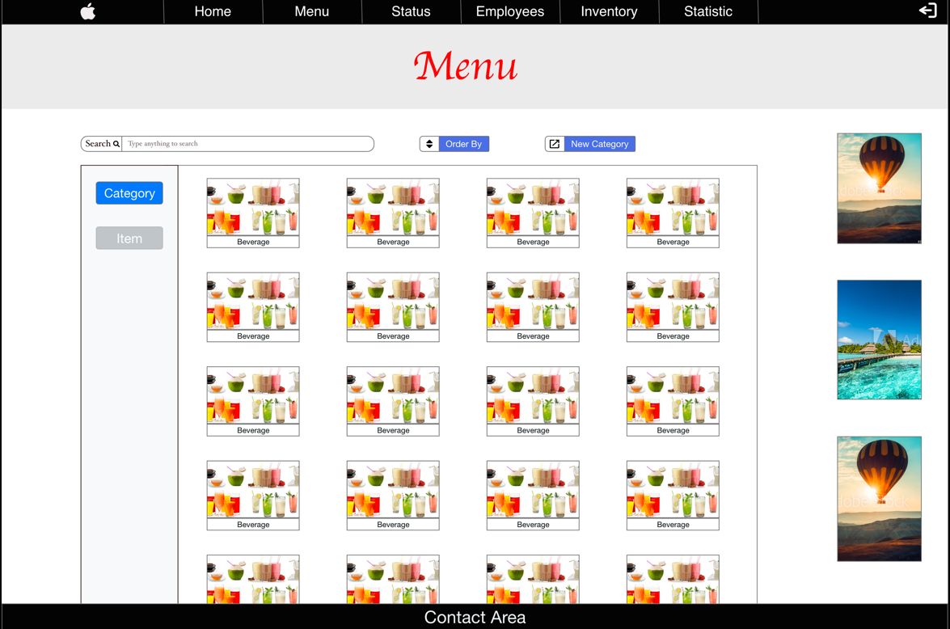

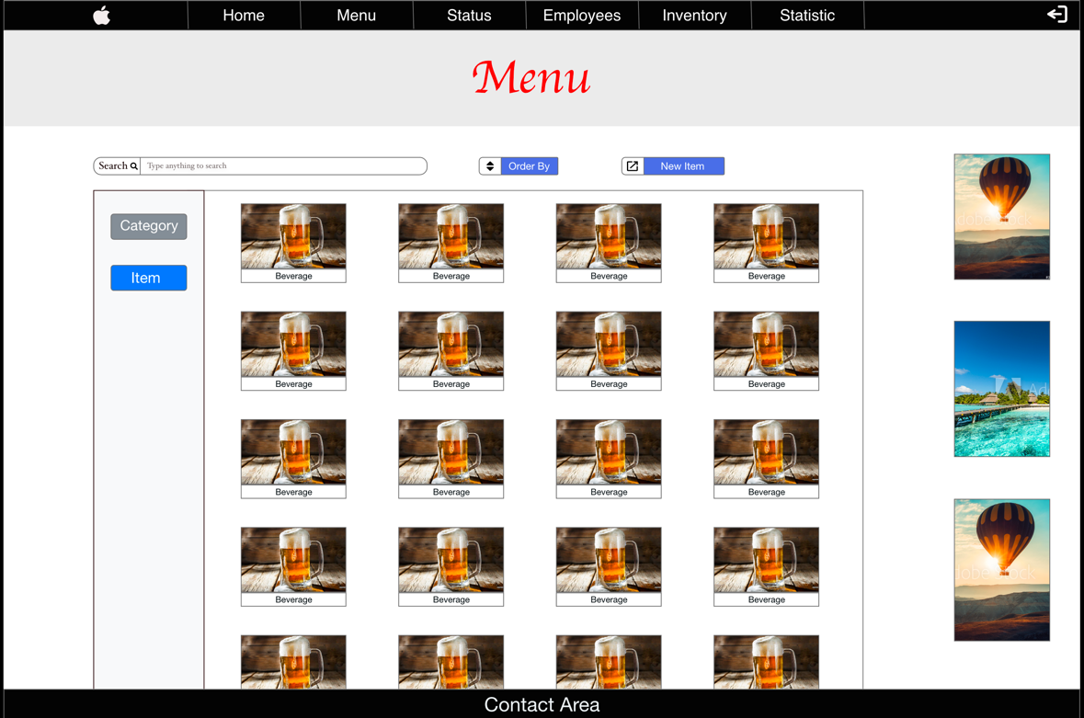

Users can also create a new category and a new item which relate to specific category.

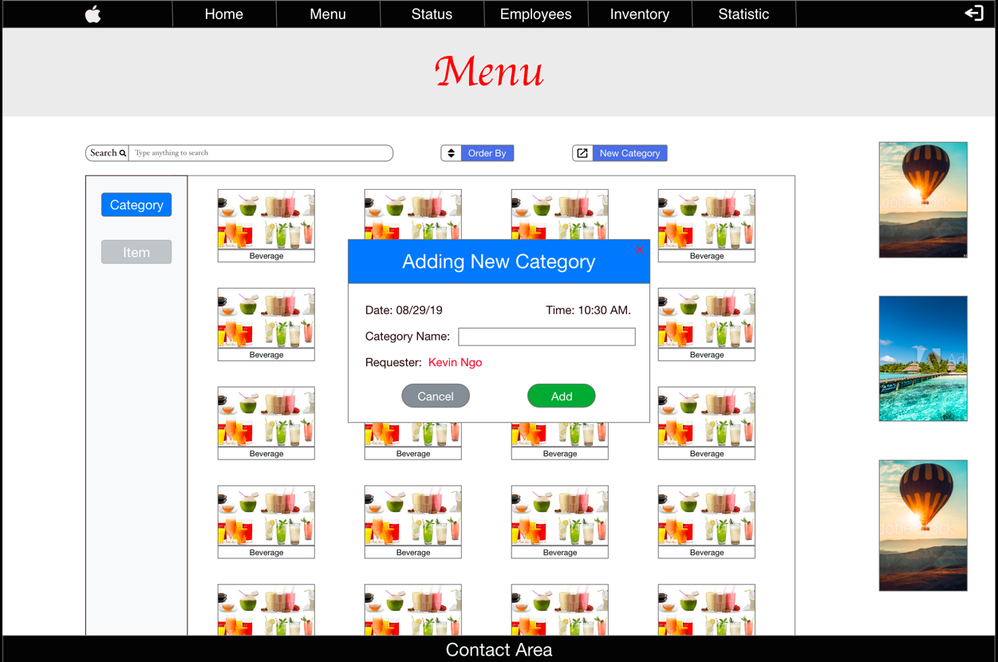

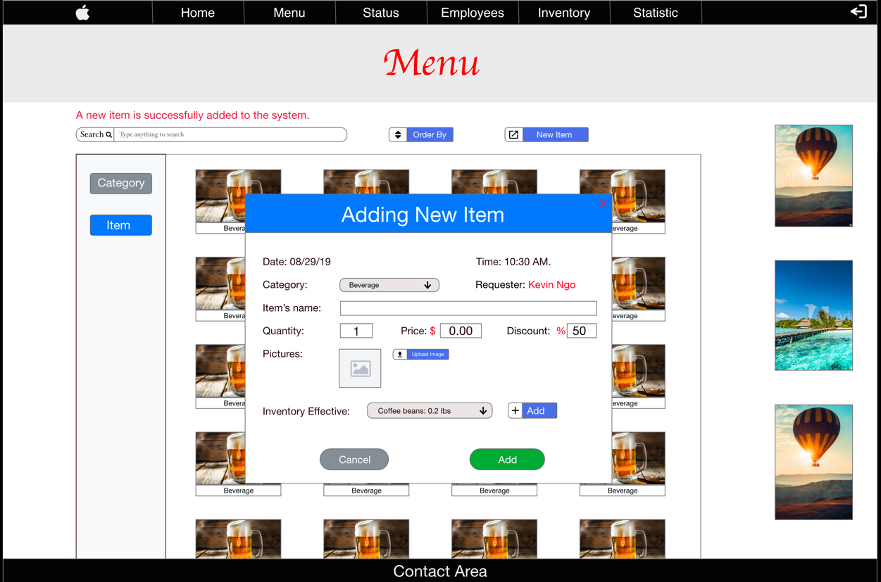

For each item, we do provide users to identify which inventory-item can be affected if an item is sold.

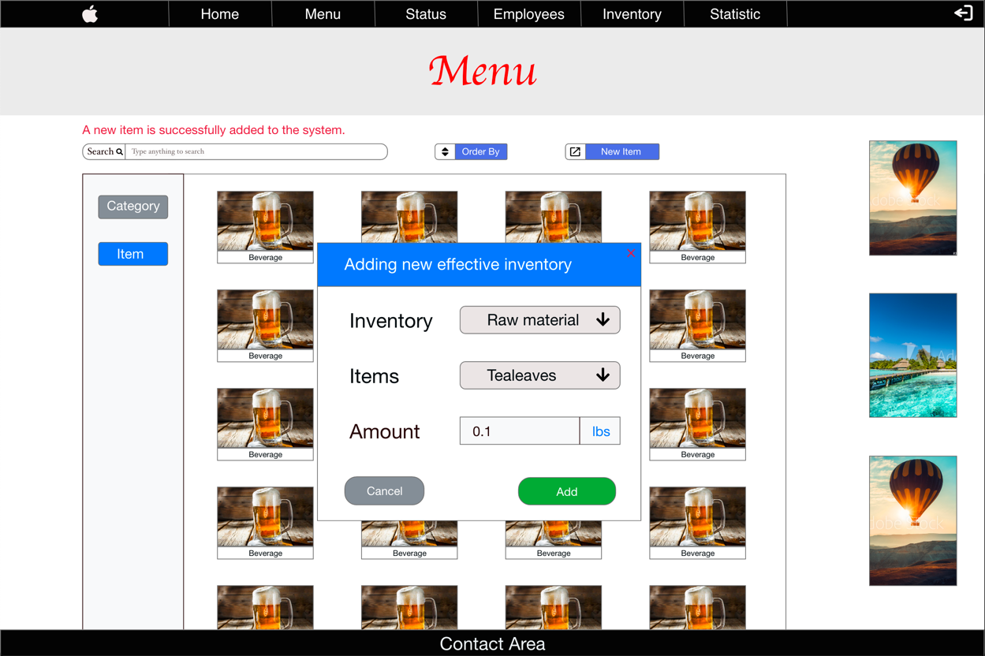

## Status Visualization

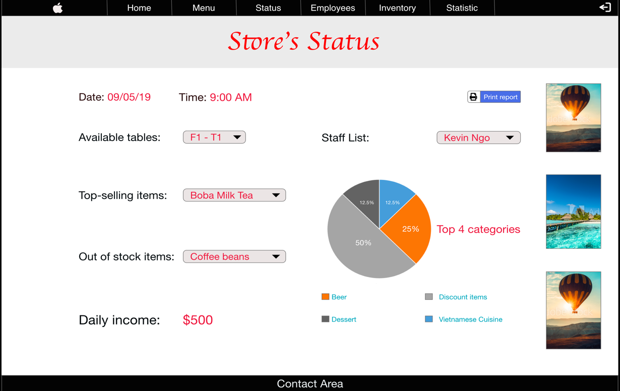Users can view and monitor store’s status in a specific day.

## Employee Visualization

Users can see the list of employees and perform some basic features.

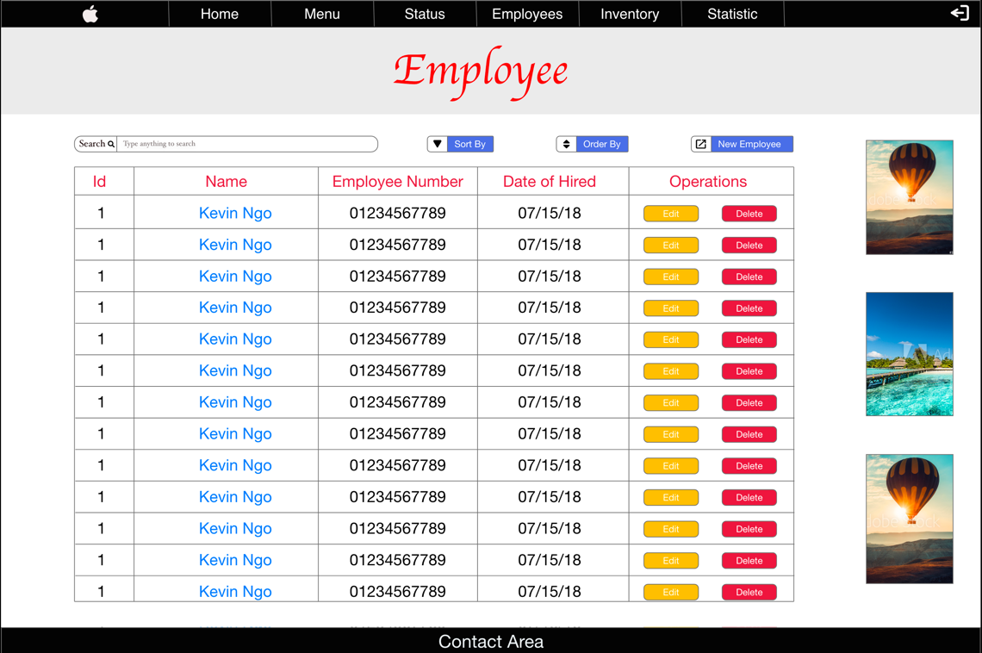

When users can click to an employee’s name to see the detail information.

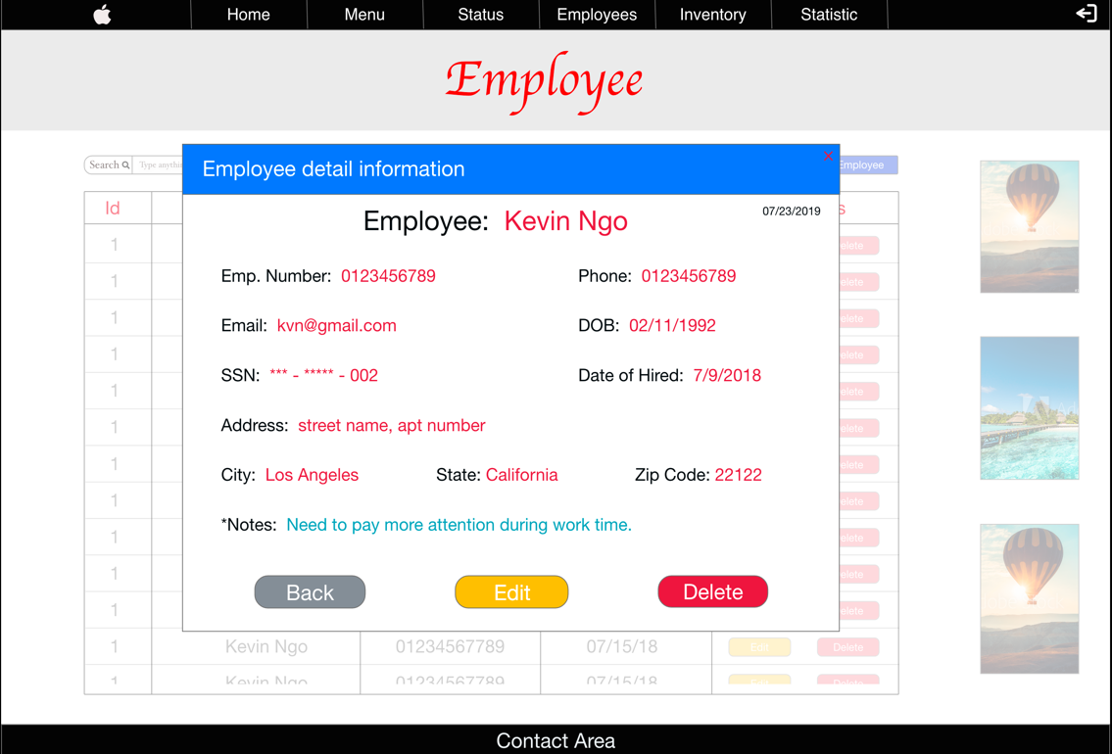

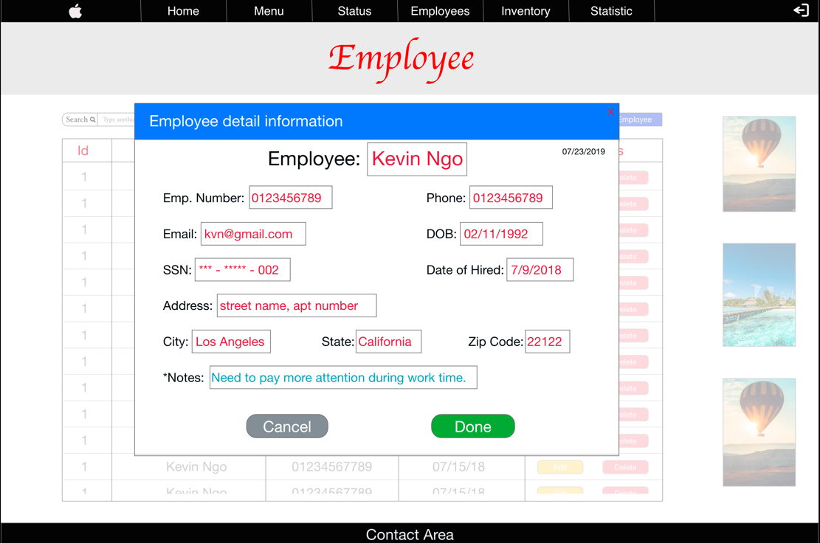Users will be able to edit an employee’s information or delete it.

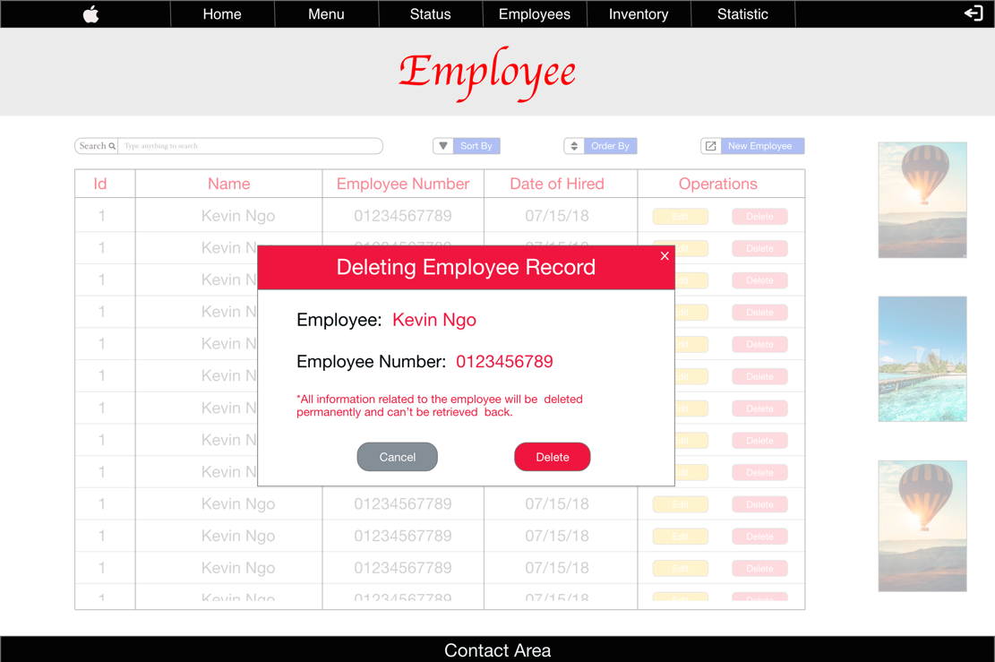

On top of that, POS System for Coffee Shops also support users to create a new employee

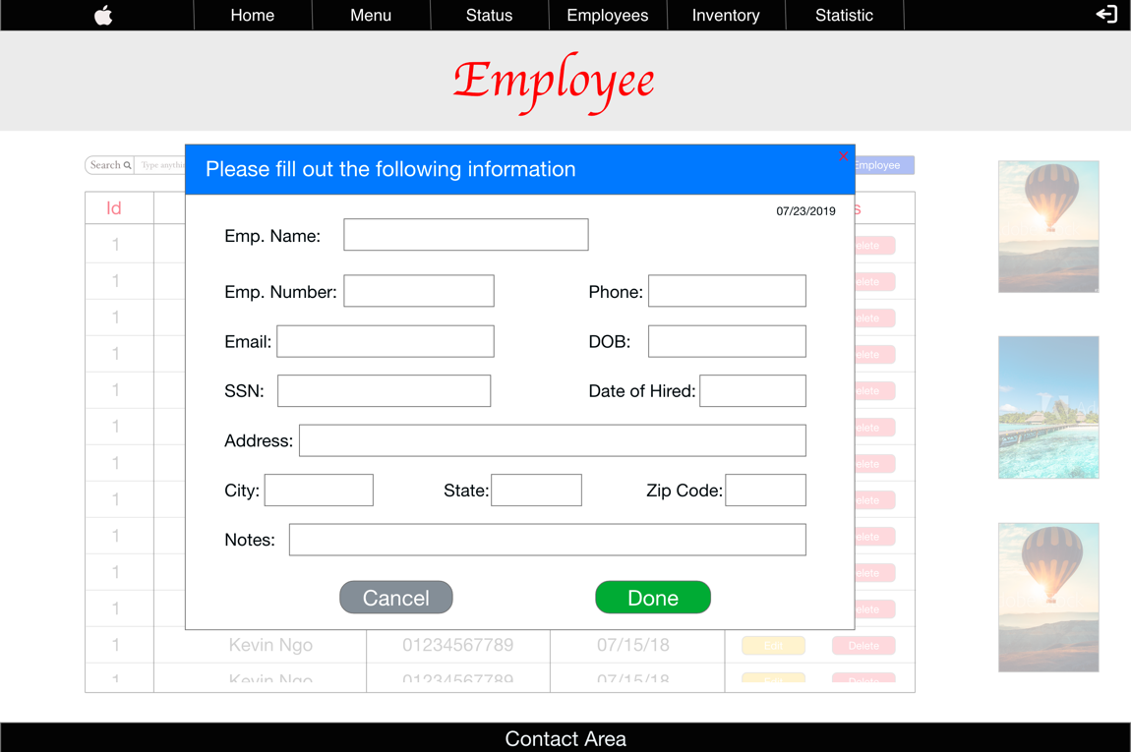

## Inventory Visualization

Users can see the list of all inventories and perform some basic features.

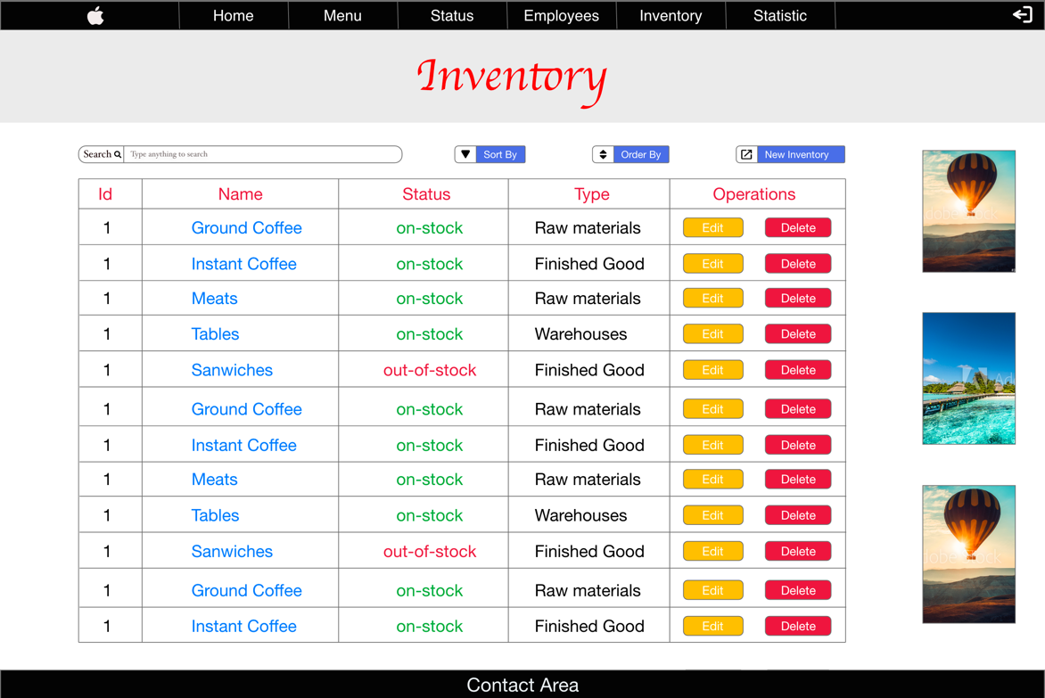

Users are capable of creating a new inventory, editing and deleting an inventory information.

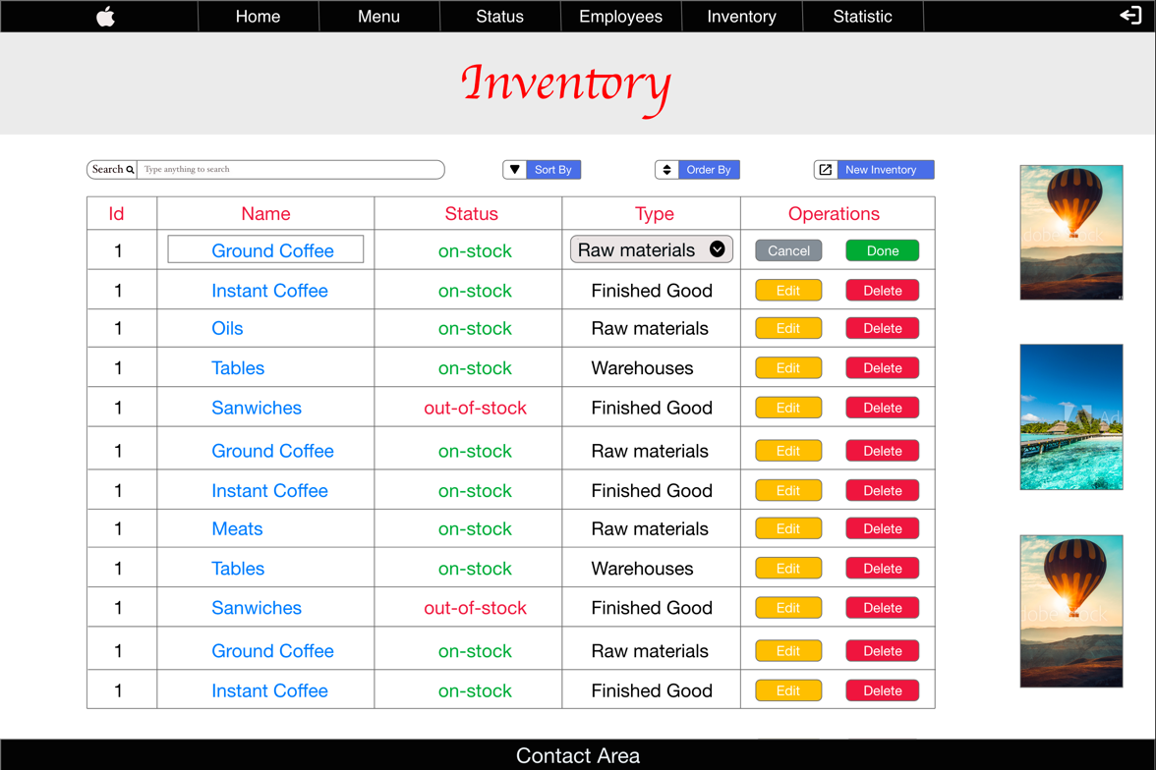

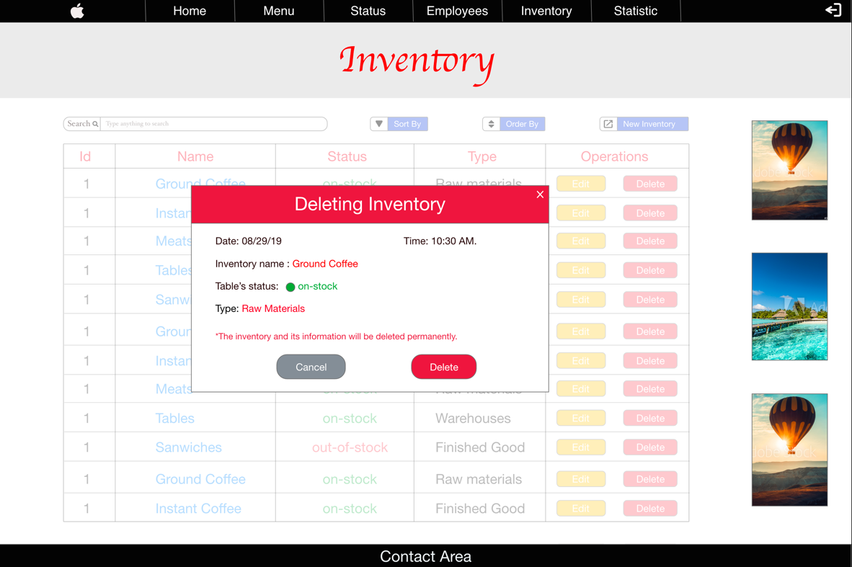

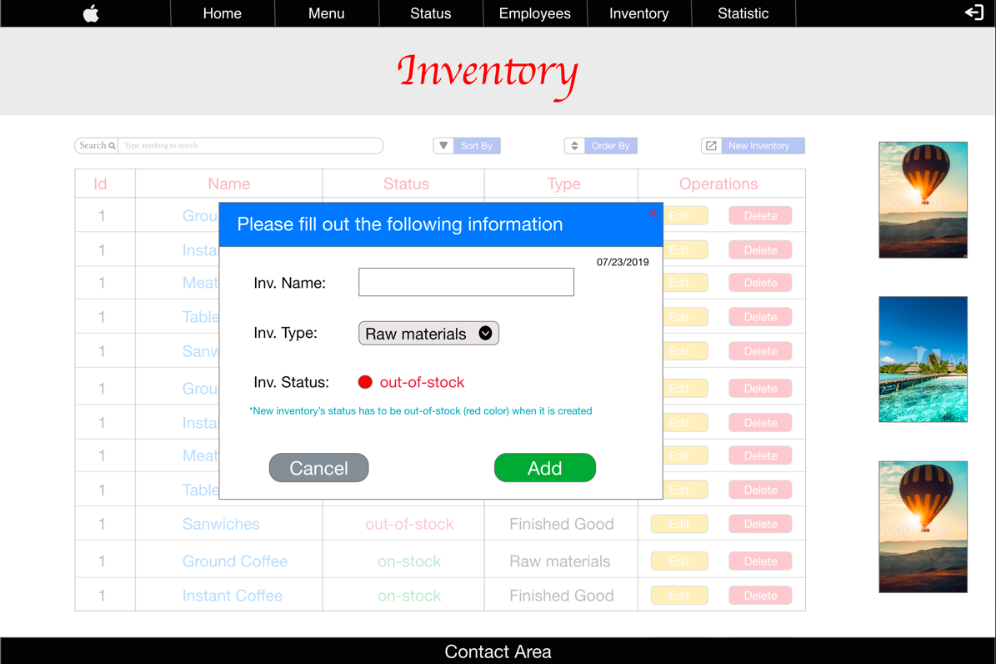

When users click to an inventory’s name, they can see the list of items related to the selected inventory.

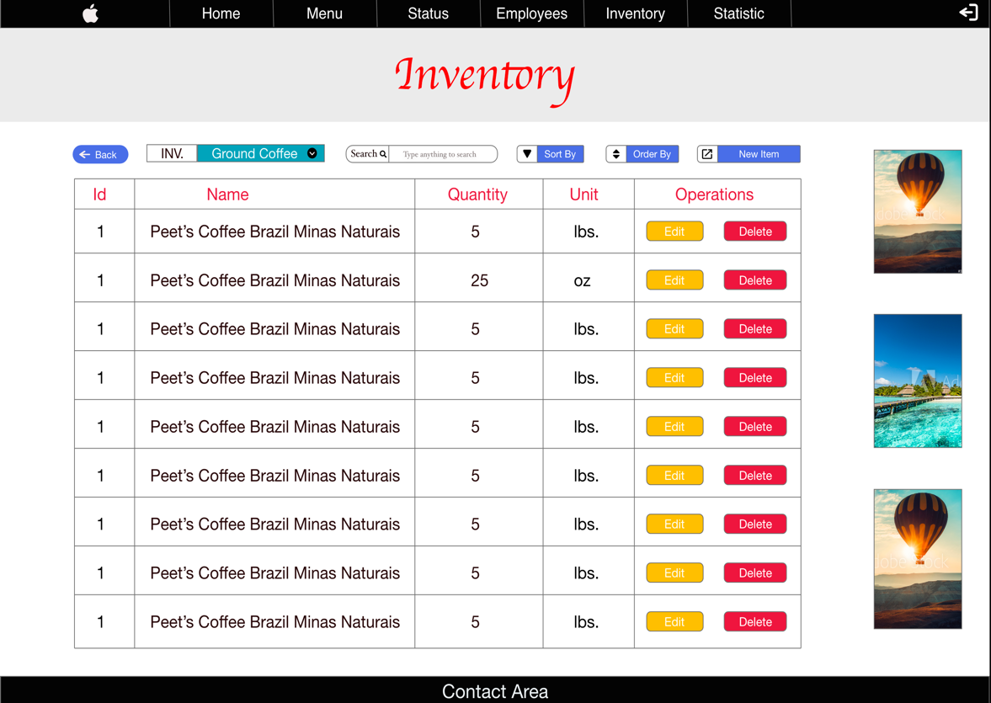

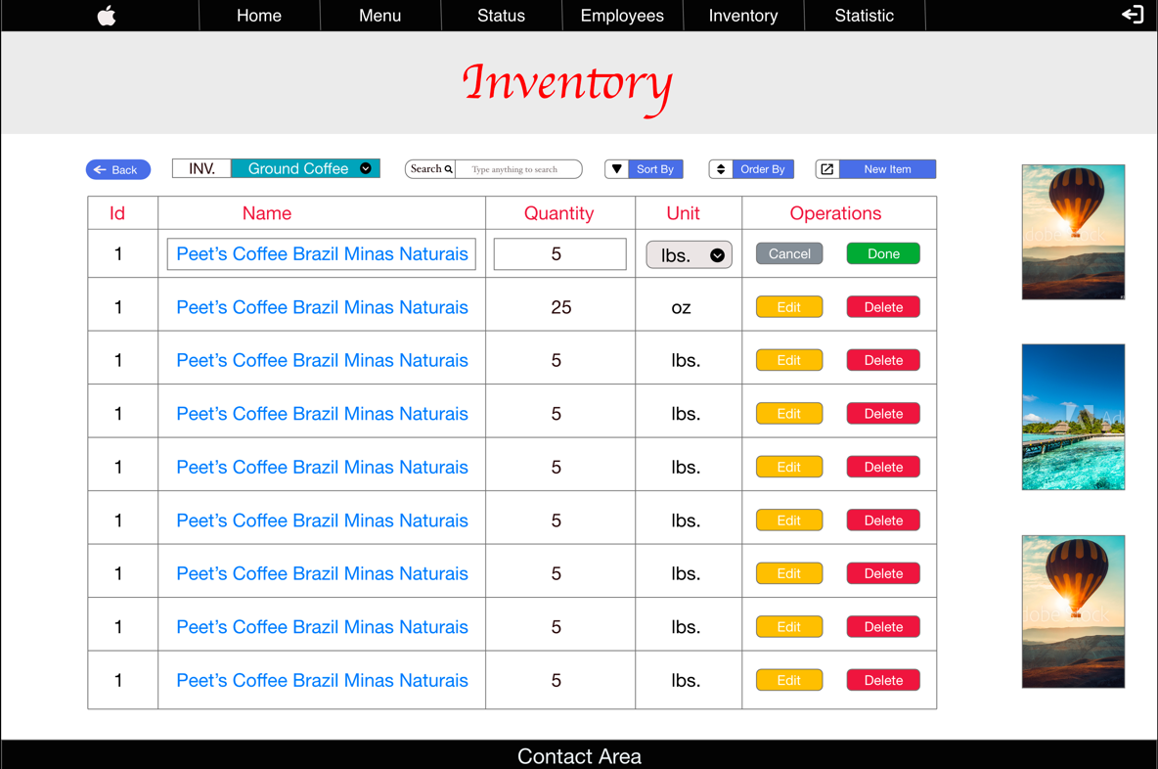For each item, users can edit and delete its information. On top of that, they also can create a new item.

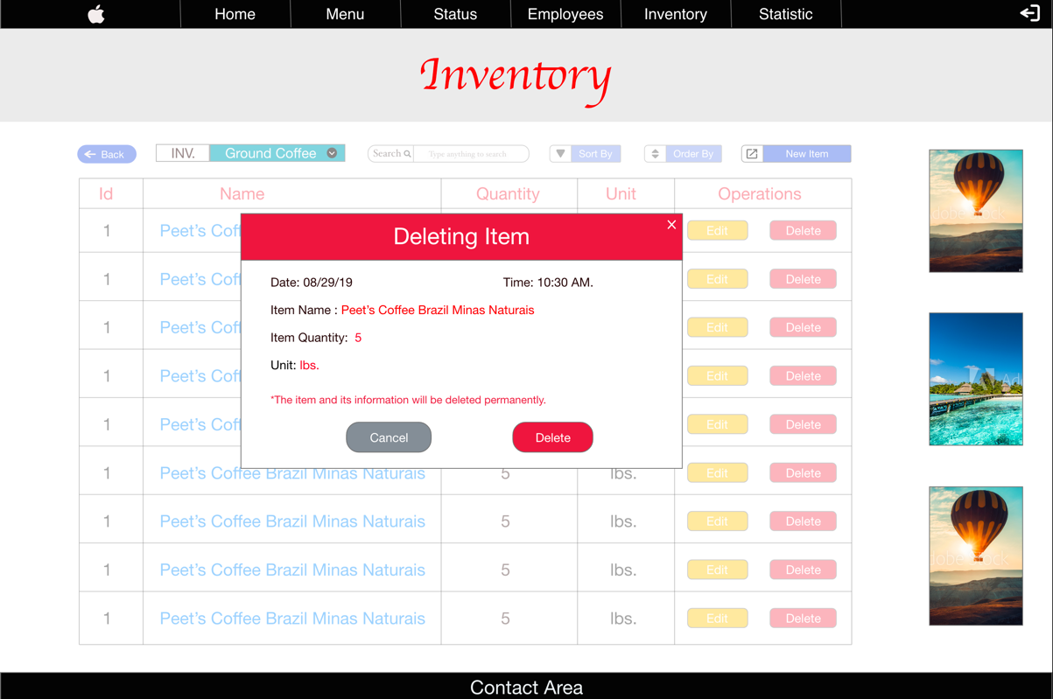

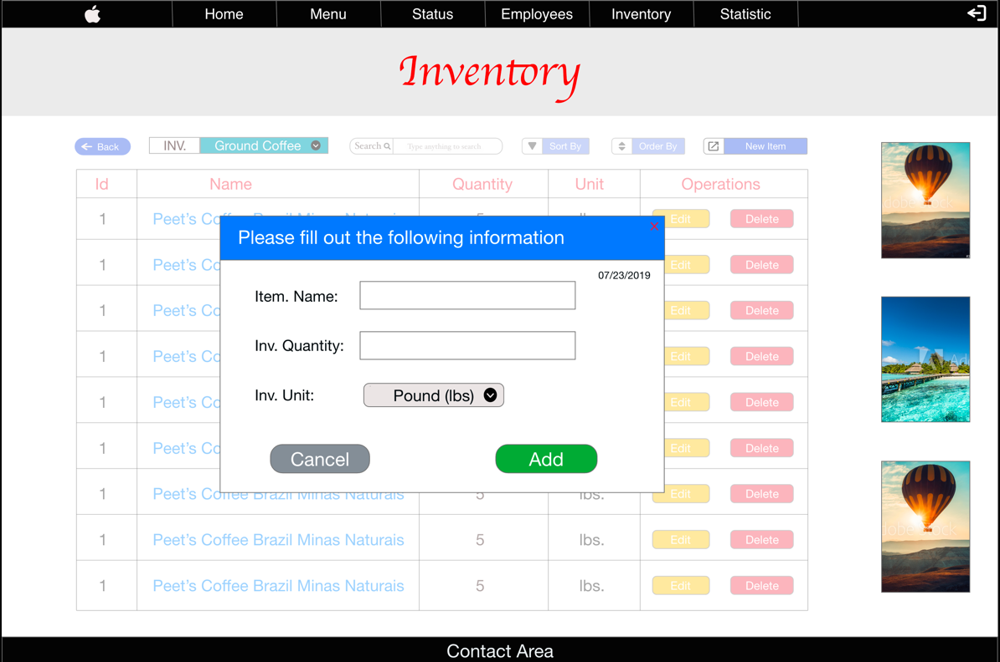

## Statistic Visualization

Users can monitor store’s statistic which can be represented by daily, monthly, or yearly.

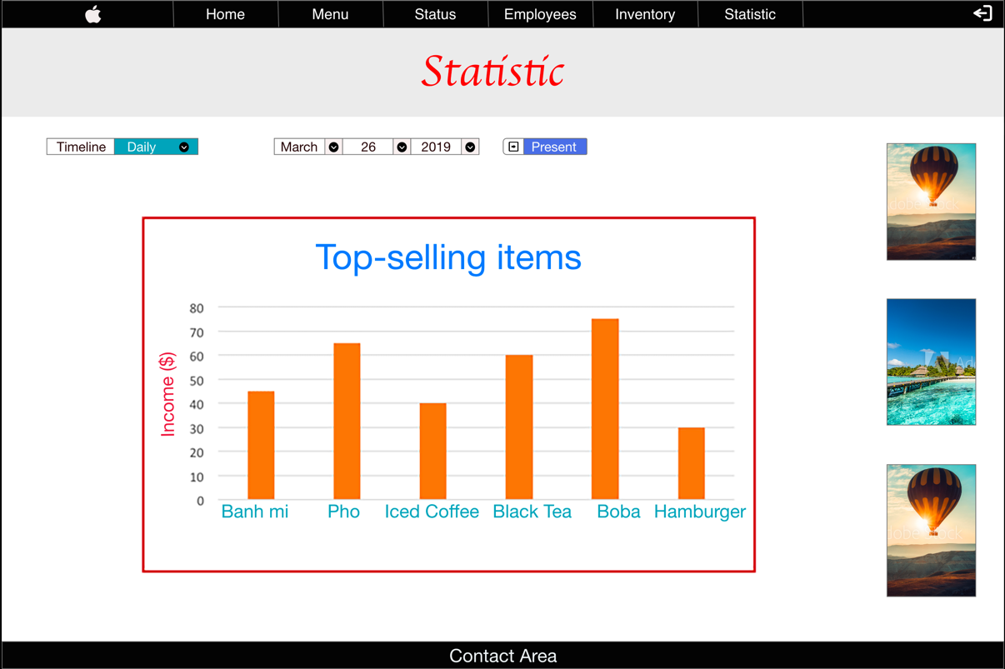

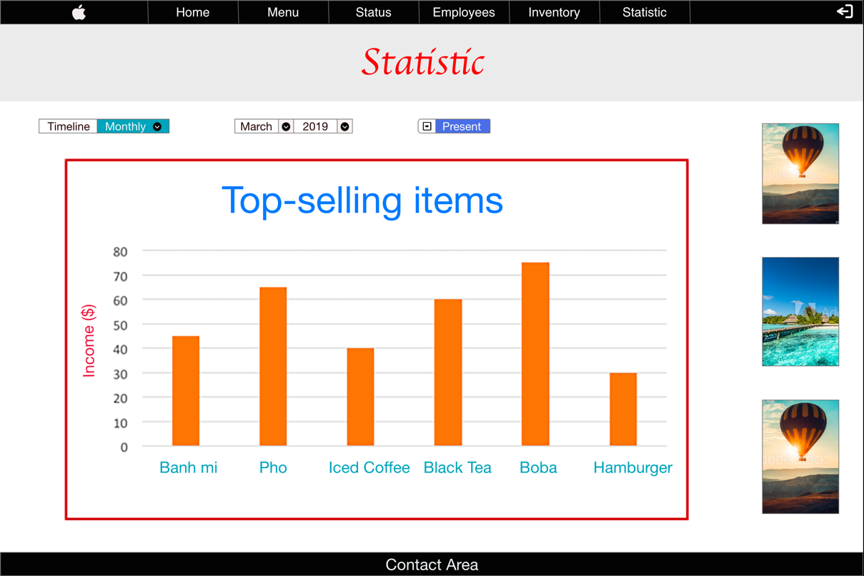

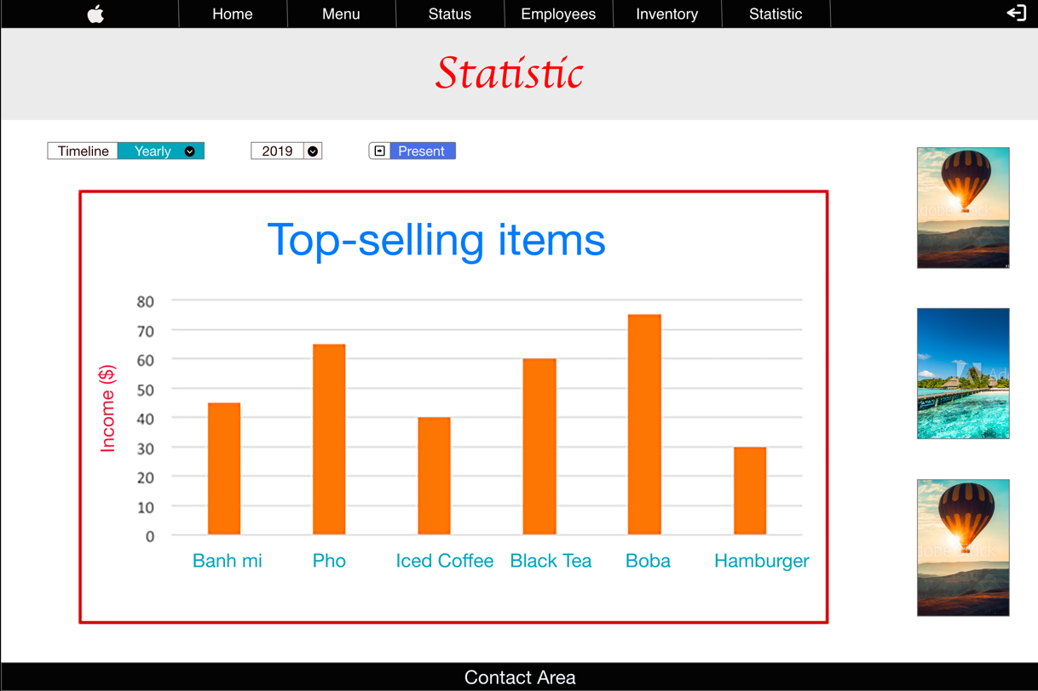

# Other Nonfunctional Requirements

## Performance Requirements

POS System for Coffee Shops is required to perform features smoothly without having any major problems.

## Safety Requirements

After performing features, POS System for Coffee Shops should be able to display messages regarding to the action, including error messages.

There should be a bug tracker available where users can report any bugs, they have encountered so that the developers can fix it in the next release.

## Security Requirements

POS System for Coffee Shops should make sure that each user can only perform the corresponding to their privileges.

## Software Quality Attributes

POS System for Coffee Shops provides the users with mostly basic features. Due to its well designed and easy to user interface it can be used by both experts and typical users.

However, users need to read product’s documents and tutorials to utilize product’s features ideally.

## Business Rules

POS System for Coffee Shops is a web application for coffee shop owners who want to use this application to manage their store.

There are 3 type of users: admin, staff, and customer.

* For customer, our website will display the list of all category in the store for them. When they click to a category, the list of items will be display for customer to choose. For each item, it should display its name, price, discount (if applicable), and picture.
* For staff, POS System for Coffee Shops will allow them to see the list of all table. Staff will be able to click to each table’s image to see its detail information.
  + If users click on the table’s name, it will show brief information about the table, such as date, time, name, floor number, status, and estimated order total.
  + After clicking to the table’s picture, staff will see the table’s order in which include list of order’s items. The screen should display table’s name and staff’s name who is currently working. They can also add a new item to each table based on what customers ordered. To add an item to a table, staff should choose a category first, then select the corresponding item with the category. The staff can’t select any item before choosing a category. On top of that, staff can perform basic operations related to every table, such as print receipt, print order, or make a payment.

As customers, staff also can access the menu tab to see what categories or items the store has. However, staff can’t add any new category as well as item to menu page.

* For admin, they technically can do everything. More specific, they have access to the following tabs:
  + Status: which will demonstrate the status of the store for the current date and time. The screen should display the following information: list of available tables, list of staff who are currently working in the store (it is desirable to have a clock in/out system for staff), list of top 5 selling items, list of out-of-stock items at that time, daily income so far, and top 4 categories which have most purchased items. There should be a print report button which will print a report with that information above.
  + Employee: which will help the admin to manage their employee information. The screen should display the list of employees with their basic information, such as id, name, employee number, and date of hired. To look at more detail of employee information, the admin can click on an employee’s name. An employee information should include the following information: name, employee number, email, phone, dob, SSN, date of hired, address (including street, city, state, and zip code), and notes or comments from admin. With those information has red color, they are required and can’t put empty.

For the operations, admin should have the basic privilege: edit, delete an employee’s information. Admin can perform 2 mentioned operations by either click on the employee’s name or directly from the main screen of the Employee page.

On top of that, admin can add a new employee by providing the information, which each employee should have, listed above.

* + Inventory: which will allow admin to manage their store’s inventory. The screen should first display the list of all inventory in the store. There are 4 inventories: raw material, finished goods, warehouse, and others. After clicking to an inventory’s name, the screen will direct users to the list of all items related to the selected inventory. At this time, the screen should also display the name of the selected inventory somewhere and allow users to navigate to another inventory-item page.

For each inventory-item, it should include the following information: id, name, quantity, and unit. For example, we create an inventory called “meat” which can be listed as raw material. When we click on “meat” inventory, the screen will be directed to the list of items of “meat” inventory. Then, we create an inventory-item named “beef” with “10” as its quantity and “lbs.” as its unit.

For operations, both inventories and inventory-items should have basic operations, such as add, edit and delete.

* + Statistic: which will display

# Other Requirements

There are no special requirements need to be included.